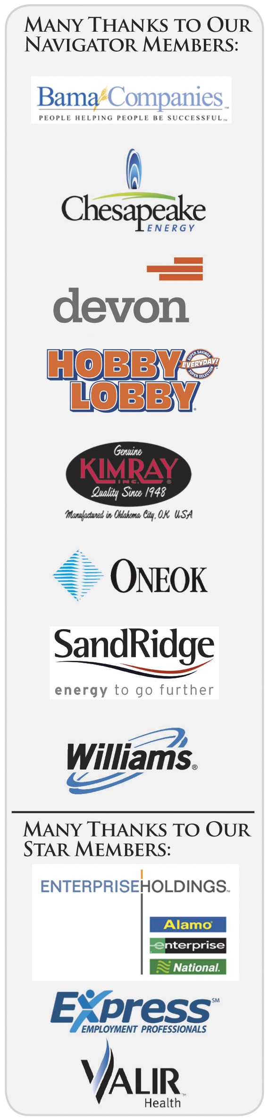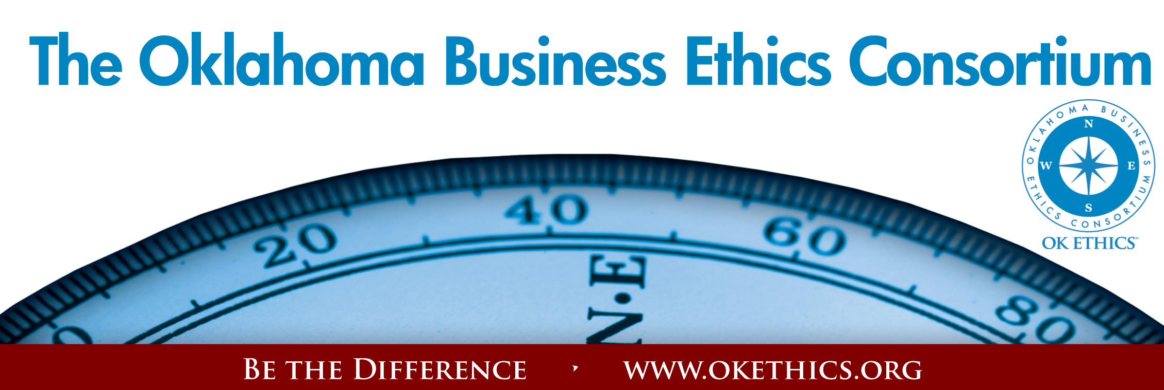Agenda – April 26, 2011
Compass Awards
- Welcome Garyl Geist, President, OK Ethics State Council
(Chief Operating Officer, Oklahoma Allergy & Asthma Clinic)
- Words of Inspiration Reverend Phil Greenwald,
St. Luke’s United Methodist Church
- University Honors Pam Fountain, President, OK Ethics Foundation
(Chief Executive Officer, Principal Technologies, Inc.)
- Congratulations to OCU and OU for winning regional Ethics Bowls in OKC, San Antonio and Cincinnati!
- Special thanks to UCO for hosting 2010 statewide competition!
Outstanding University Advisors:
Dr. Barbara Crandall – Oklahoma City University
Dr. Stephen Ellis – University of Oklahoma
Dr. Bambi Hora – University of Central Oklahoma
Dr. Katherene Terrell – University of Central Oklahoma
- Board Honors Rob Martinek, OK Ethics Vice President of Risk
Management & Organizational Spirit
(Director, Legal Services, The Bama Companies, Inc.)
Recognizing David Mayfield, OK Ethics Treasurer for his
five years of outstanding service.
- Pilot Award Honoring Ted Streuli, The Journal Record
Shannon Warren, OK Ethics Founder
- Compass Awards History & Selection Team Members Garyl Geist
- Mid-Sized Company Award Presentations -
Dr. James Branscum, Superintendent, Metro Technology Centers
Mike Lyles, Chief Executive Officer, LCI, Inc. (2009 Honoree)
Honorable Mention for Best Practices in Mid-Sized Company -
HoganTaylor, LLP
Pelco Products Inc.
Awardee: Coppermark Bank, Thomas Legan, Chief Executive Officer
OK Ethics’ first two-time award winner!
- Honorable Mention for Best Practices in Large Company Category –
The Bama Companies, Inc. – Randy Thurman, Co-President & CFO of Retirement Investment Advisors (2010 Honoree)
ONEOK – Todd Lisle, Managing Partner, BKD, LLP (2008 Honoree)
- Presentation of Compass Award to Devon Energy – Oscar Jackson, Administrator of the State of Oklahoma Office of Personnel Management; Administrator and Cabinet Secretary of Human Resources
Awardee: Devon Energy, Larry Nichols, Executive Chairman and Co-Founder

- Introduction of Guest Speaker Bob Byrne, OK Ethics Foundation Board Advisor
(Retired Boeing)
- Keynote Speaker – Oklahoma Secretary of Veterans Affairs, Rita Aragon: “Ethics for Patriots”
- Upcoming Events Shannon Warren

- Adjourn

VOLUNTEER RECOGNITION:
OK Ethics has no staff and relies on volunteers to achieve the organization’s successful pursuit of Oklahoma’s values of integrity at work.
Registration Team: These dependable individuals show up every month to diligently record our guests’ attendance and handle the collection of fees:
- Mark Neumeister, D. R. Payne & Associates: Co-Chairperson
- Mary Vaughan, CPA; Co-Chairperson
- Joe Walker, Grant Thornton LLP: Co-Chairperson
Compass Award Registration Team Members:
Bobby Redinger, Cole & Reed
Lucius Crandall, SandRidge Energy
Ambassador Team: These friendly people welcome our guests each month and assist in helping them locate seats:
Team Leaders:
- Tere Bettis, Coppermark Bank: Co-Chairperson
- Linda Streun, Ideal Homes: Co-Chairperson

Team Members:
Debra Cooper – Bank of Oklahoma; Brent Martens - Accounting Principals; Arete Muse - Vericrest
Financial; Ginger Castleberry – Valir; Sheila Winn; - Integris Health; Larry Musslewhite – OESC;
Deana Howe – Hertz; Melanie Thompson-Stillinger - HLP Solutions; Wayne Hart – Prepaid Legal;
Tonya Purvine – Valir; Dr. Earlene Smith – Rose State College; Ray Belford – First Christian Church,
Shawnee; Kristy Boone - Ideal Homes; Lynette Martin – Oklahoma City University

Agendas: Linda Manaugh and Trish Potter, Metro Technology Centers
Logistics: Jamie Potter, Eide Bailly
Name Tags: Kim Whyburn, Devon Energy
Accounts Receivable Reconciliation: Susan Pate, Stinnett & Associates
Pre-meeting Slide Show & AV: Connie Rutz, Maximum Multimedia
Photos and filming: Ted West, Digital West
Member Care Coordinator: Deborah Gavula, Principal Technologies, Inc.

Join our team - Contact our leadership
  - Programs: Shannon Warren, Founder, OK Ethics warrenokla@cox.net or 858-2233
  - Membership & Recruiting: Shannon Hiebert, Vice President of Human Resources,
Enterprise Rent-A-Car; Shannon.Hiebert@erac.com or call 330-9191
  - Public Relations: Kellian Schneider, Owner, FullForce Branding & Marketing; kellian@fullforcebusiness.com
  - Ambassador Co-Chairs: Tere Bettis, Vice President of Human Resources, Coppermark Bank, TBettis@coppermarkbank.com or Linda Streun, Director of Human Resources,
Ideal Homes, lindastreun@ideal-homes.com
  - Registration: Mark Neumeister, D. R. Payne; 272-0511; moneumeister@drpayne.com

OK ETHICS VISION:
To be recognized as a statewide and national forum for
promoting business ethics.
pROMOTING oKLAHOMA VALUES OF INTEGRITY AT WORK
Attendance since FY2004/05:
Year | OKC* | Tulsa | Total | Avg
2004-05 | 1059 | 252 | 1311 | 111
2005-06 | 1277 | 535 | 1812 | 151
2006-07 | 2118 | 752 | 2870 | 239
2007-08 | 1951 | 800 | 2751 | 250
2008-09 | 2401 | 921 | 3322 | 332
2009-10 | 2668 | 1058 | 3726 | 373
2010-11 | 1817 | 667 | 2484* | 375
* YTD
OKC includes Moore/Norman statistics
Fiscal year basis 10/1 to 9/30
YTD Attendance 2010 – 2011:
Chapter | Oct | Nov | Dec | Jan | Feb* | Mar | YTD | Avg
OKC | 247 | 279 | 276 | 280 | 251 | 249 | 1582 | 264
Tulsa | 89 | 144 | 82 | 136 | 104 | 112 | 667 | 111
Workshops | 28 | 27 |  |  | 180 |  | 235
Total YTD |  |  |  |  |  |  | 2484 | 375
Preview of Upcoming OK Ethics Events
NOTE DATE CHANGE: May 18, 2011
“Building Trust in Customer Relations”
General Program Disclaimer:
Members of the Oklahoma Business Ethics Consortium frequently share information concerning various issues and developments that may have legal implications. The discussions, commentary, and handouts at Consortium meetings or presentations to other organizations are for general informational purposes only. They cover only some aspects of the subject topic, and do not constitute a complete legal analysis of the topic or how it might apply to any particular set of facts. Before taking any action based on information presented during a Consortium event, participants are encouraged to consult a qualified attorney. The observations and comments of presenters at Consortium meetings and networking are the views and opinions of the presenter and do not constitute the opinion or policies of the Consortium or any of its members.
Presenters are respectfully requested to avoid profanity, preaching, politics and self-promotion during their lectures.
A Panel Discussion
Celine Ferguson,  Senior Vice President &  Chief Financial Officer  Coppermark Bank | Pete Winemiller, Senior VP of Guest Relations for the  OKC Thunder
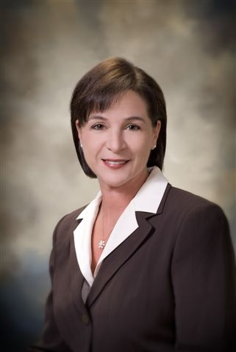 | 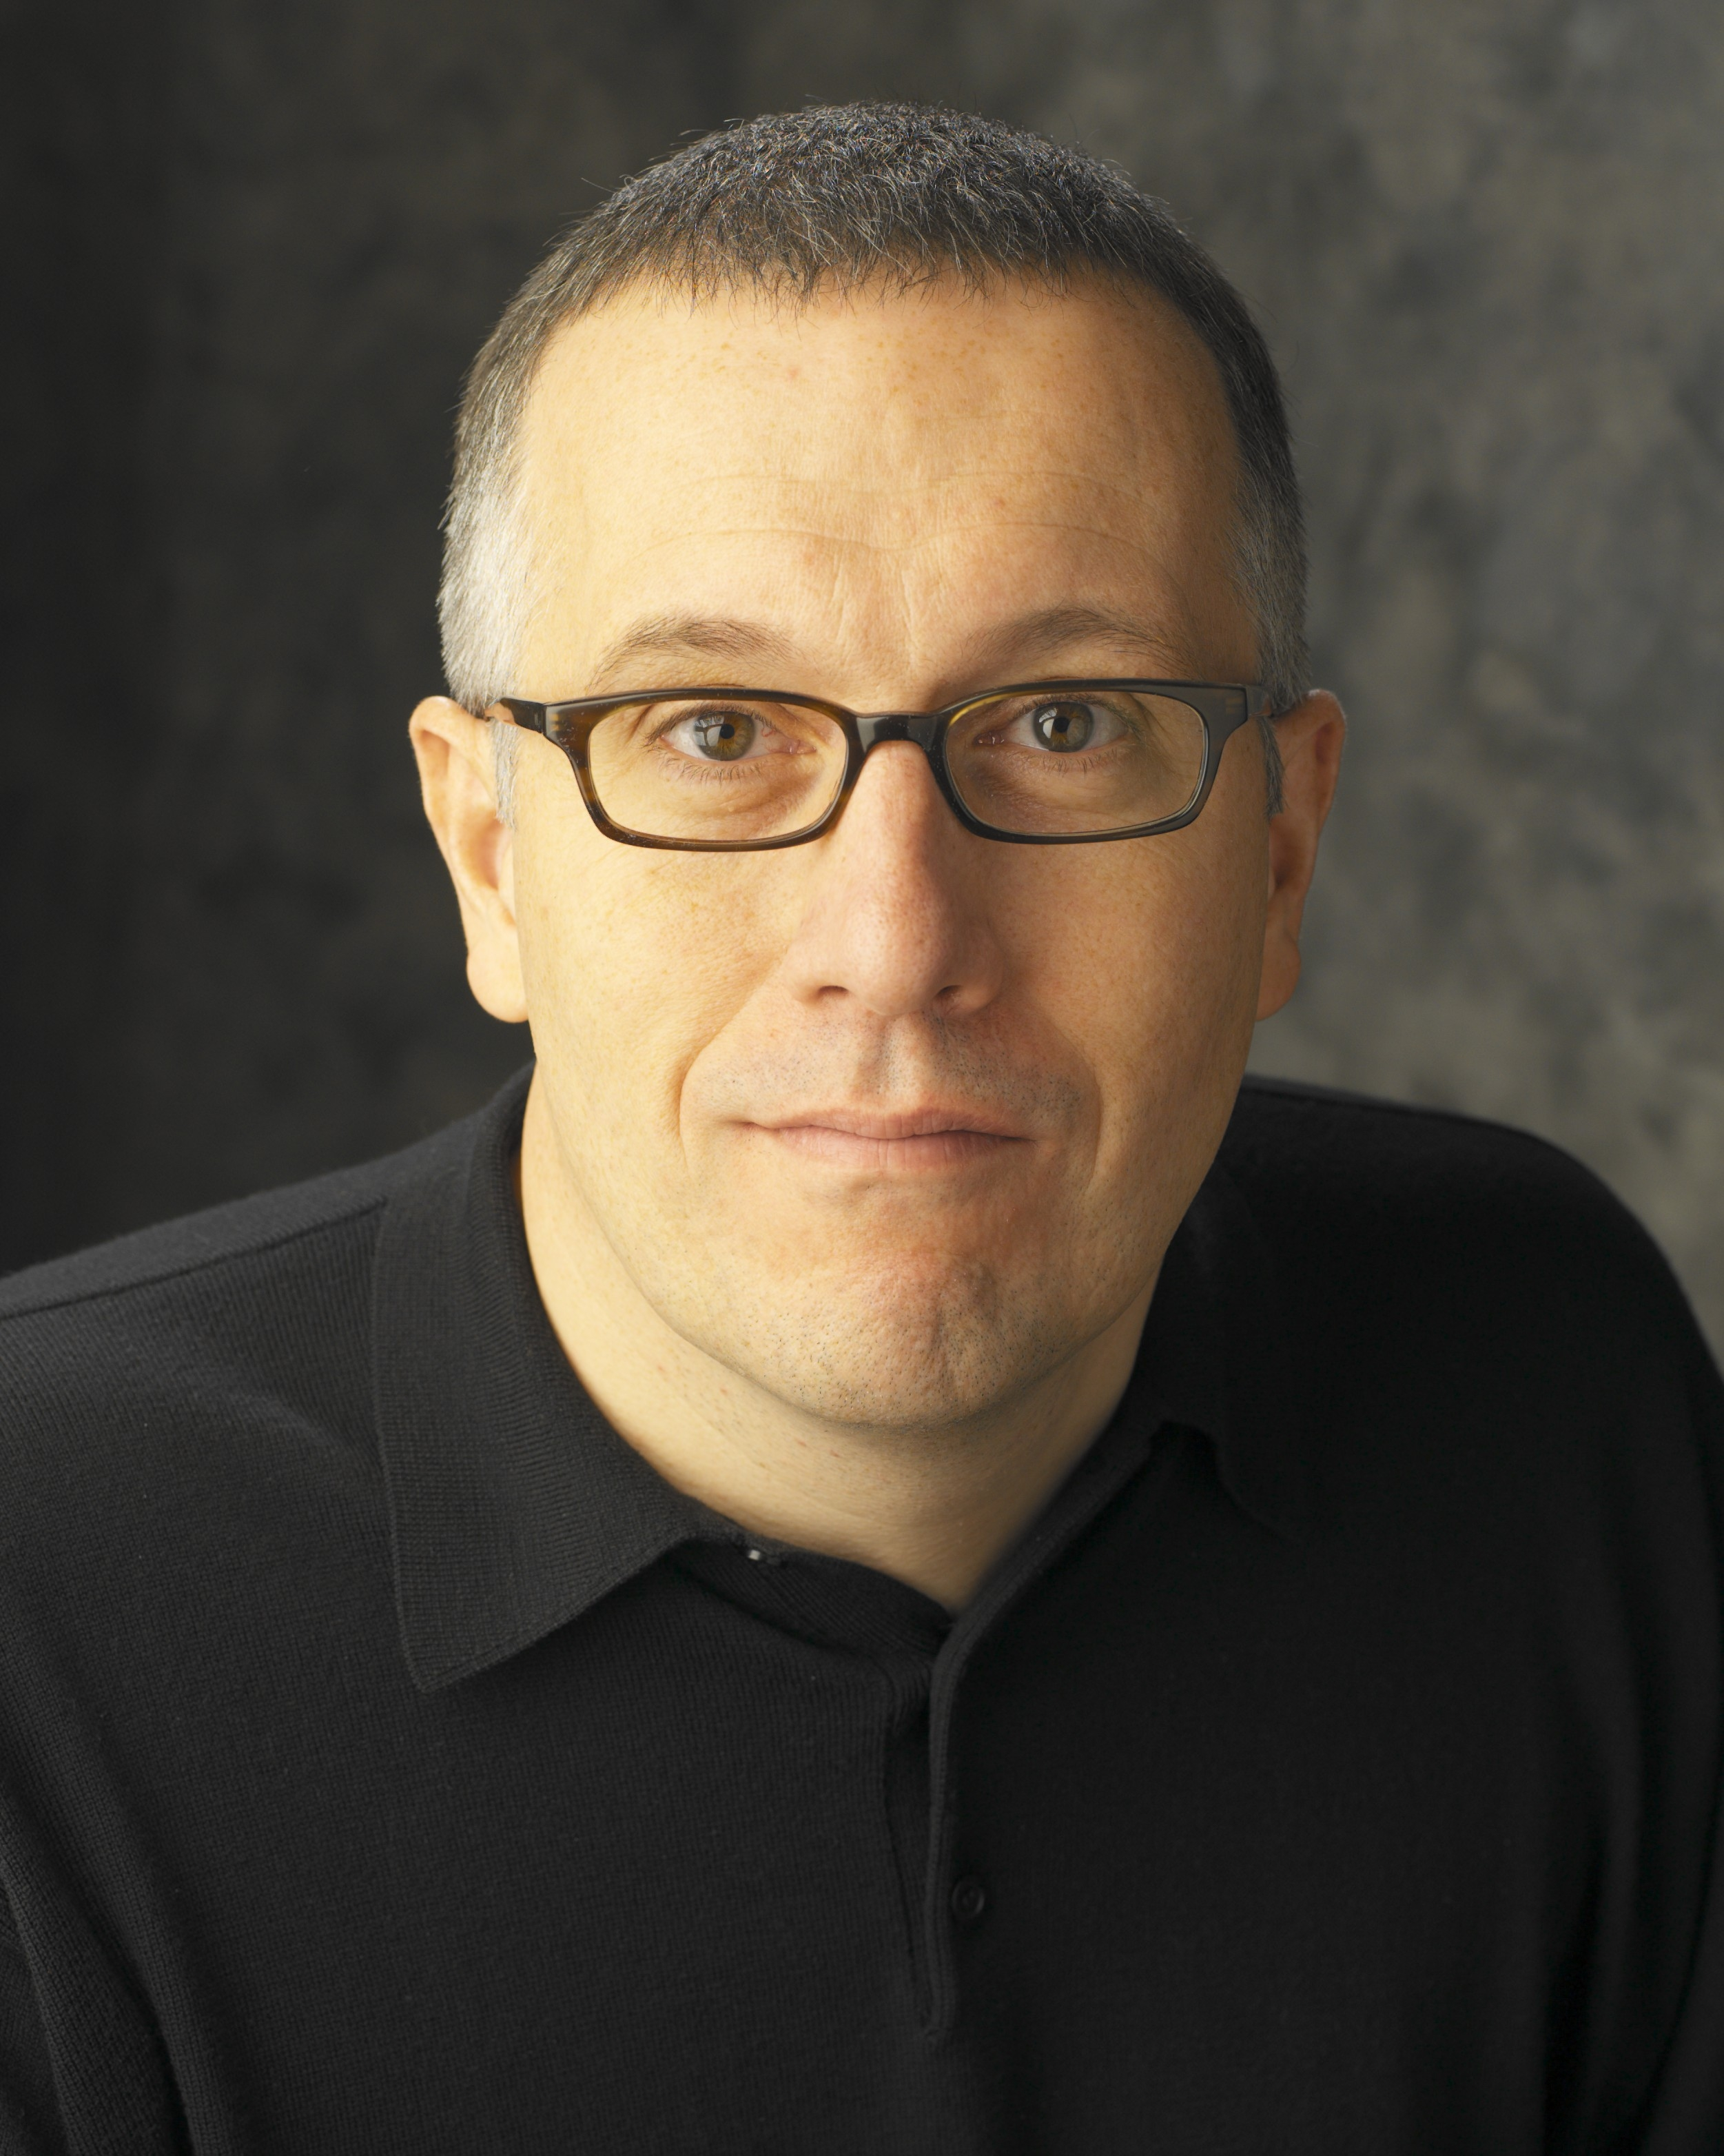
Featuring business leaders from organizations that have highly successful customer interactions. Joining the panel members listed below will be corporate trainer Timothy Hast whose focus
will be on the psychology of trust.
UPCOMING EVENTS FOCUSED ON INTEGRITY AT WORK (Not affiliated with OK Ethics)

For nearly eight years, we have been inspired by our friendship with the Character First Institute. Leaders with that organization provided the wisdom and insight for OK Ethics’ Guiding Principles.
All events are by invitation only. To learn more about the Character First Institute, please contact John Burnett or Steven Menzel at 405-815-0001 for a personal invitation.

