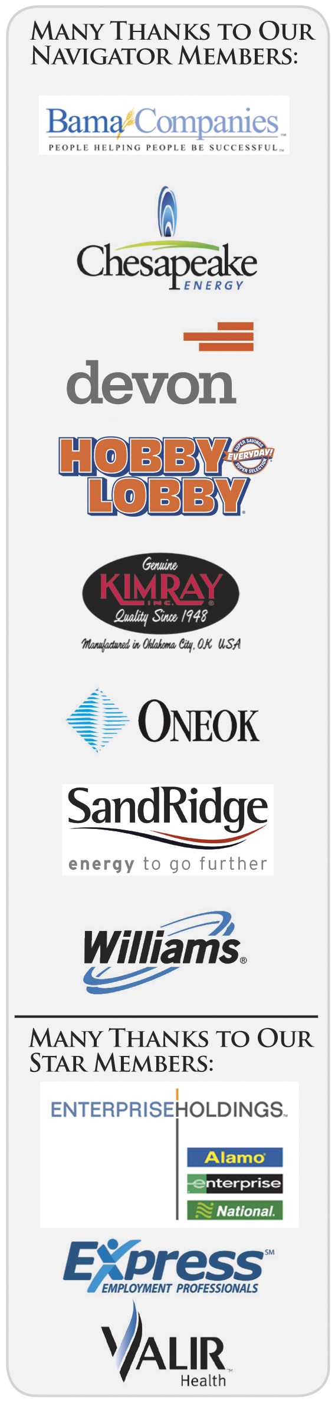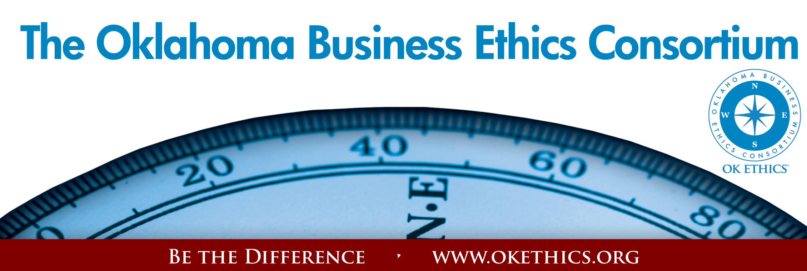Agenda – August 10, 2011
- Welcome & Announcements
- Intentional Interaction - How do you define integrity? What are some of the ways someone can distinguish greed from healthy ambition?
Note: OK Ethics encourages interaction among our members for the purpose of building relationships with others who share an interest in promoting Oklahoma values of integrity at work. At the same time, this is not an appropriate forum for sales activities.
- Join/Renew Now - OK Ethics Annual Membership Drive Underway
- Statewide Student Ethics Challenge – Oct. 29 at Okla Christian
- Upcoming Events – Shannon Warren, Founder, OK Ethics
- Keynote Speaker: Tom Pace, Pace Butler; author of The Mentor
- Adjourn

- Welcome & Kudos Garyl Geist, President, OK Ethics;
Chief Operating Officer, Oklahoma Allergy & Asthma Clinic
- Membership levels: No dues or meals increase for FY11-12
$7500 – Navigator = Prepaid for16 attendees at each event + Compass Awards with a portion of dues donated to the OK Ethics Foundation supporting our educational initiatives.
$5000 - Oklahoma Stars = Prepaid for 8 attendees at each event + Compass Awards with a portion of dues donated to the OK Ethics Foundation supporting our educational initiatives.
$3000 – Horizon = Prepaid 8 attendees at each function except Compass Awards.
$1500 – Leading = Prepaid 2 attendees at each function including Compass Awards.
$ 500 – Trailblazer = Prepaid 1 attendee at each function except Compass Awards.
$ 350 – Frontier = 8 attendees at each function; meal costs excluded
* Complimentary memberships are available for 501c3 qualified non-profits.
$ 75 - Scout = 1 attendee at each function; meal costs excluded
*Complimentary memberships are available at the Scout level for those who have been recently laid off.
RENEW/JOIN BY SEPTEMBER 9 TO BE INCLUDED IN SPECIAL PROMOTIONAL BOOKLET - Will be distributed at the October meeting.

Many thanks to these flagship companies for their early renewal and continued commitment: ONEOK, Ideal Homes and Oklahoma Baptist University!
REMINDER: PICK UP CPE’S AT CONCLUSION OF THIS MEETING

Oklahoma Business Ethics Consortium Guiding Principles
Adopted July, 2004
To ensure that the Consortium fosters positive characteristics of integrity in the successful achievement of its goals, these Guiding Principles were discussed and adopted (with revisions) during a milestone planning session held by Consortium leaders in Stroud on June 18, 2004. These principles were developed based on the Character First Institute's values and philosophies.
I. Responsibility to Self and Others:
- Service:
  - Passion for promoting ethics and integrity
  - Encouraging the promotion of ethical behavior through personal actions and
  - Sharing ideas and resources
  - Responsibility and accountability for fulfilling the mission of the Consortium.
- Collaboration:
  - Achievement of common goals through the promotion of ethical, mutually beneficial relationships
  - Service to the Consortium over promotion of self-interest
  - Cooperation emphasized over competition in promoting ethical business conduct
  - Members collaborate by being constructively engaged in discussions regarding ethics
  - Seeking consensus in interactive discussions regarding ethical matters.
- Respect:
  - Members may become aware of confidential information shared by others in an effort to determine an ethical course of action. We ask members to be sensitive in recognizing and respecting the efforts made toward achieving ethical behavior. In that vein, public disclosure of this information is discouraged.
  - We respect other members and the process by:
    - Exhibiting listening skills and actively listening to discussions
    - Being open to other points of view and outcomes
  - We are an inclusive organization and demonstrate this by welcoming members who are in different stages of learning as applied to ethical behavior.
II. Lead with Integrity
- Dependability:
  - Members are asked to demonstrate their support of this initiative by consistently attending meetings.
- Initiative:
  - Recruiting other members who have demonstrated a desire to promote ethical behavior in their organizations.
  - Recognizing what needs to be done to help promote the Mission of the Consortium and taking action to assist in that effort.
- Honor:
  - Members are asked to honor the Consortium through the practice of integrity and ethical behavior in their business dealings.
  - We express gratefulness to our hosts, sponsors and speakers.
  - Realizing that each of us is in a mode of continual learning, we demonstrate humility, care and compassion when sharing our thoughts and knowledge.
- Courage:
  - Speak the truth with confidence and encourage others to do the same.
III. Inspire Trust
- We serve and promote the cause of truth with integrity, objectivity and fairness to all persons.
  - We hold ourselves accountable by consistently honoring our word.
  - We extend trust abundantly to those who have earned it.
  - Trust, once earned, will not be taken for granted, manipulated or abused.

VOLUNTEER RECOGNITION:

CPE CERTIFICATES
It is the responsibility of participants to demonstrate applicability of each program as it relates to his/her area of practice. OK Ethics makes no guarantees. Also, attendees must be present to accept CPE certificates and these will be issued at the back of the room upon the conclusion of the program. Please note that we do not have the manpower capabilities to email these later. CPE certificate recipients must be registered on our attendance list to receive a certificate, so please be sure to check in with the registration team.
OK Ethics has no staff and relies on volunteers to achieve the organization’s successful pursuit of Oklahoma’s values of integrity at work.
Registration Team: These dependable individuals show up every month to diligently record our guests’ attendance and handle the collection of fees:
- Mark Neumeister, Co-Chairperson; D. R. Payne & Associates:
- Mary Vaughan, CPA; Co-Chairperson
- Joe Walker, Chairperson (Prepaid members); Grant Thornton
- Marvinette Ponder, (Prepaid members); Devon Energy
Ambassador Team: These friendly people welcome our guests each month and assist in helping them locate seats:
Team Leaders:
- Tere Bettis, Coppermark Bank: Co-Chairperson
- Linda Streun, Ideal Homes: Co-Chairperson

Team Members:
- Arete Muse, Vericrest Financial
- Wayne Hart, Prepaid Legal
- Brent Martens, Accounting Principals
- Jenny Hatton, Boeing
- Jenny Juvera, Ideal Homes
- Scott Harris, Oklahoma Baptist University
- John Burnett, Character First

Agendas: Bertha Robinson, Metro Technology Centers
CPE certificates: Michael Mount, Oklahoma Accountancy Board
Name tags: Kim Whyburn, Devon Energy
Accounts Receivable Reconciliation: Susan Pate, Stinnett & Associates
Pre-meeting slide show – Connie Rutz, Maximum Multimedia Creations
Join our team - Contact our leadership
  - Membership & Recruiting: Shannon Warren, Founder, OK Ethics
warrenokla@cox.net or 858-2233
  - Public Relations: Kellian Schneider, Owner, FullForce Branding & Marketing; kellian@fullforcebusiness.com
  - Ambassador Co-Chairs: Tere Bettis, Vice President of Human Resources, Coppermark Bank, TBettis@coppermarkbank.com or Linda Streun, Director of Human Resources,
Ideal Homes, lindastreun@ideal-homes.com
  - Registration: Mark Neumeister, D. R. Payne; 272-0511; moneumeister@drpayne.com

OK ETHICS VISION:
To be recognized as a statewide and national forum for
promoting business ethics.

General Program Disclaimer:
Members of the Oklahoma Business Ethics Consortium frequently share information concerning various issues and developments that may have legal implications. The discussions, commentary, and handouts at Consortium meetings or presentations to other organizations are for general informational purposes only. They cover only some aspects of the subject topic, and do not constitute a complete legal analysis of the topic or how it might apply to any particular set of facts. Before taking any action based on information presented during a Consortium event, participants are encouraged to consult a qualified attorney. The observations and comments of presenters at Consortium meetings and networking are the views and opinions of the presenter and do not constitute the opinion or policies of the Consortium or any of its members. Presenters are respectfully requested to avoid profanity, preaching, politics and self-promotion during their lectures
ABOUT YOUR PRESENTER
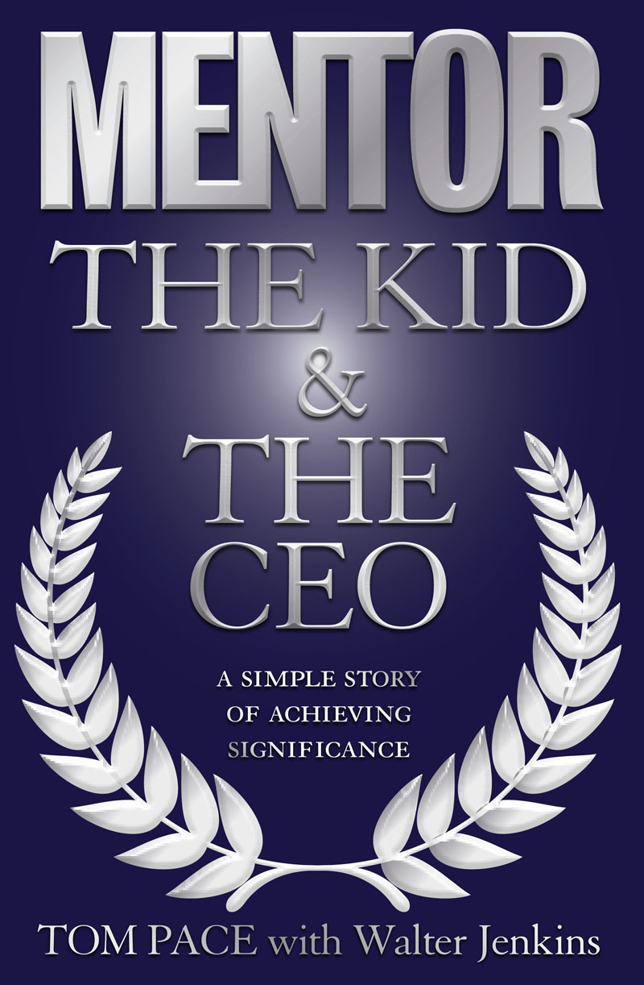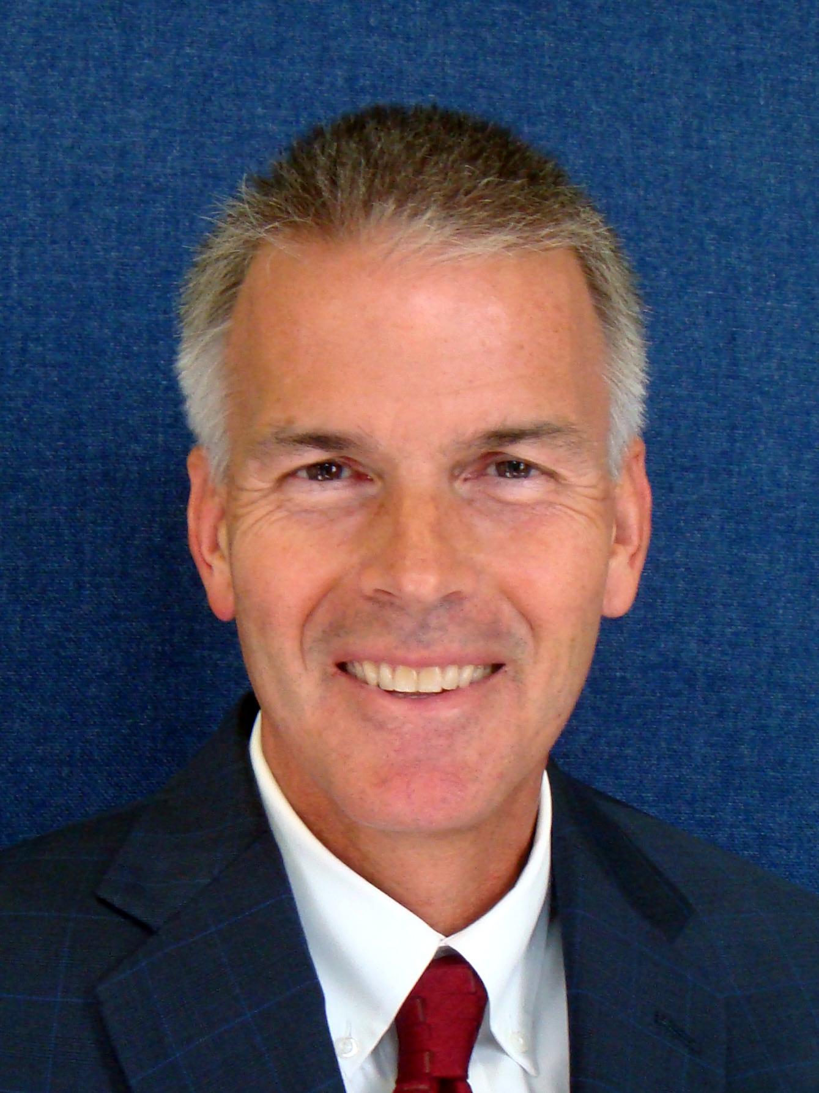Tom Pace is an energetic entrepreneur, CEO, and author who currently resides in Oklahoma City, Oklahoma. From humble beginnings, Tom has built an outstanding reputation for his dynamic business leadership, engaging charisma, and active community involvement. He speaks regularly to large audiences at corporate, not-for-profit, and educational gatherings and is noted for his ability to effectively bring to life practical ways to apply time-tested principles that have proven to be
true in his own life.
In 1987, with a personal net worth of only $62.53, he founded PaceButler Corporation His determination, entrepreneurial spirit, and ability to effectively lead people have allowed him to build the company into the multi-million dollar, international organization that it is today. PaceButler is recognized for the culture of innovation, optimism, and employee development that Tom has inspired.
This program is recommended for every business leader and professional who has faced their shares of ups and downs. Tom will bring new insights to the following topics:
1. Integrity Defined
2. Why is Confidentiality Important?
3. Difference Between Greed and Ambition
4. Loyalty vs. Profit
5. Where does temptation come from?
v. Preview of Upcoming Events Shannon Warren, Founder, OK Ethics

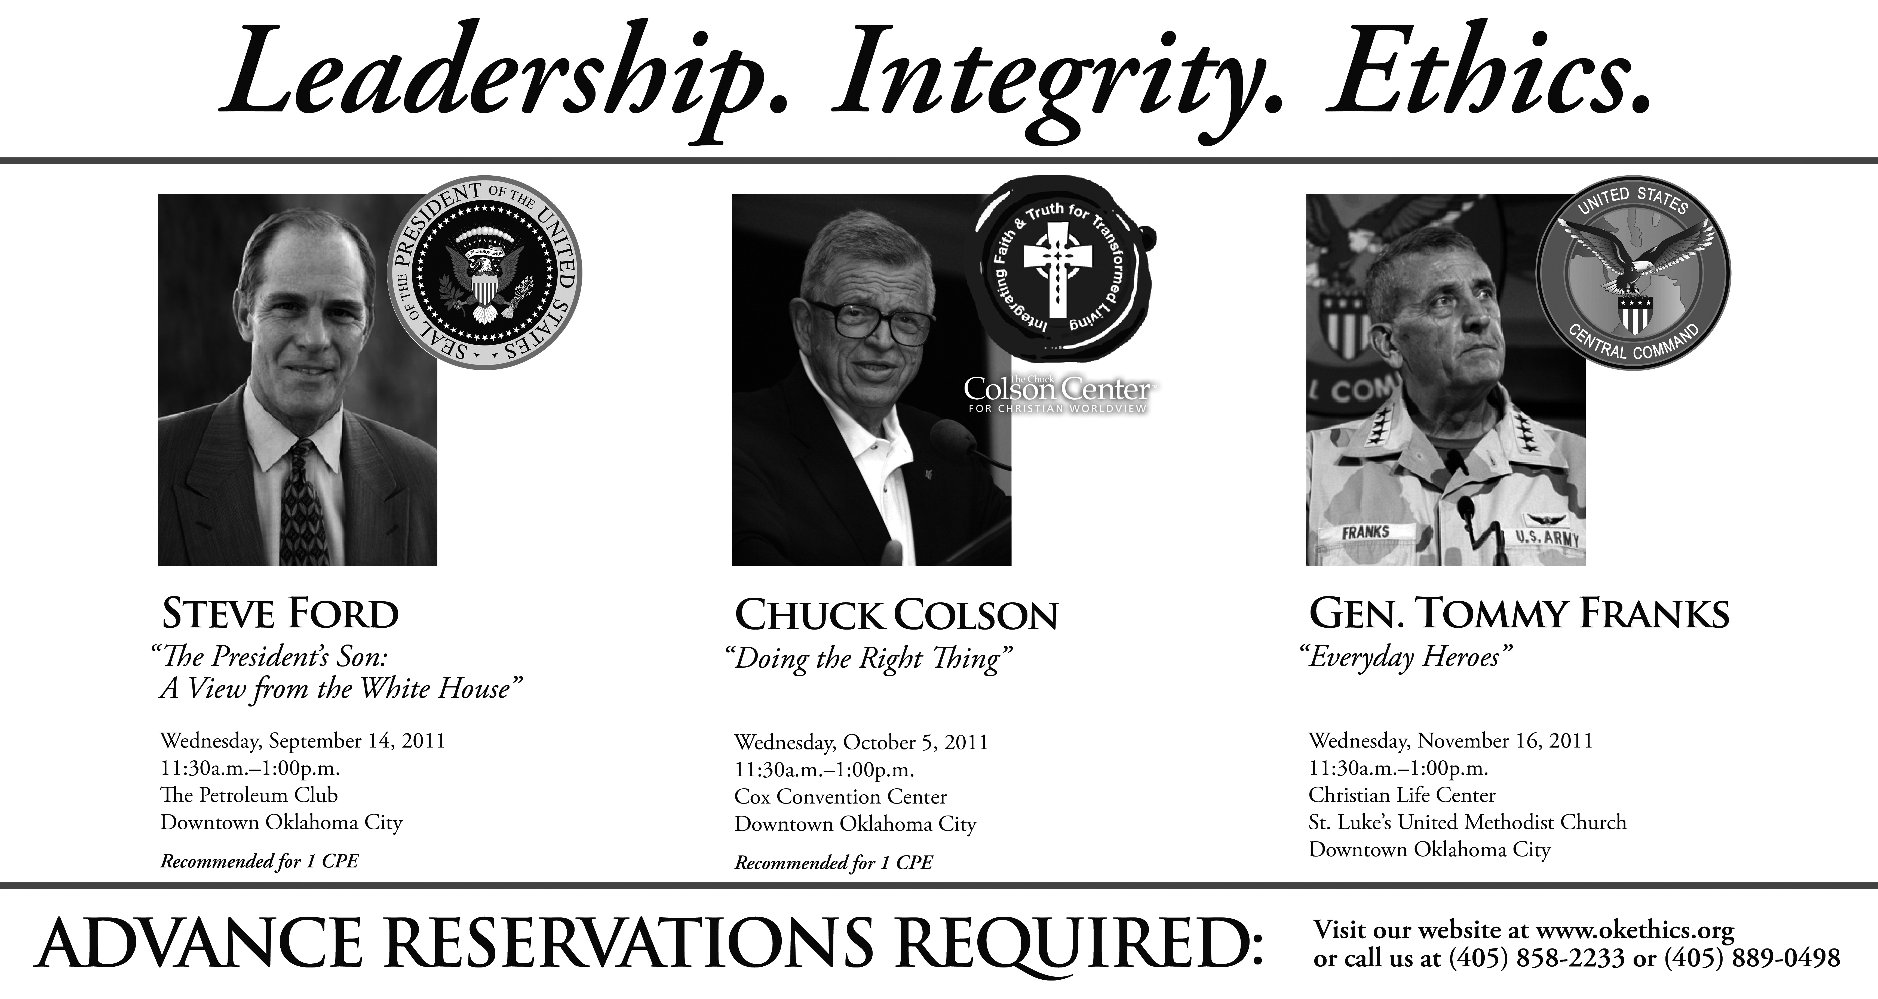_______________________________________________________________

VI. UPCOMING EVENTS FOCUSED ON INTEGRITY AT WORK
(Not affiliated with OK Ethics)

For eight years, we have been inspired by our friendship with the Character First Institute. Leaders with that organization provided the wisdom and insight for OK Ethics’ Guiding Principles.
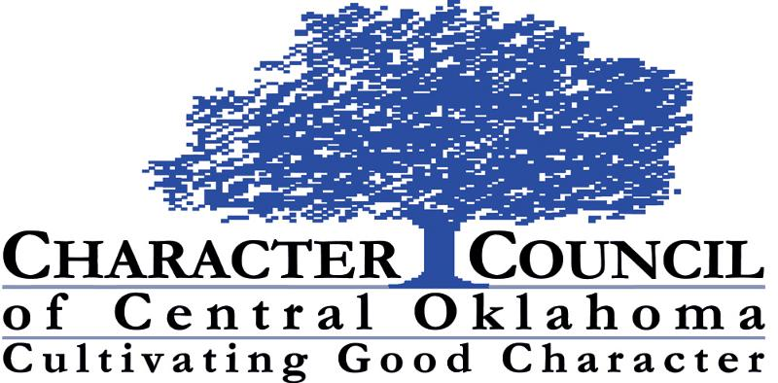All events are by invitation only. To learn more about the Character First Institute, please contact John Burnett or Steven Menzel at 405-815-0001 for a personal invitation
August 23rd Luncheon

Jean Hendrickson

Executive Director | Oklahoma A+ Schools
RSVP: luncheon@characterok.org;
.
TULSA CHAPTER PRESENTS:
"Finding True North When Everything is Going South"
presented by
Bob Goshen
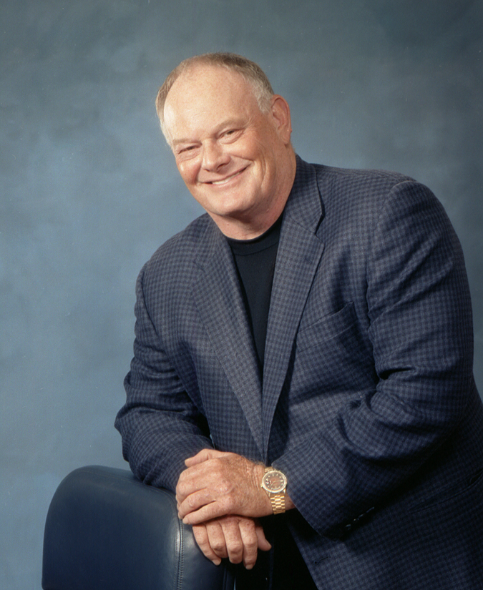Former U.S. spy and now business consultant/professional speaker Bob Goshen will speak to OK Ethics on Aug. 25. His topic will be "Finding True North When Everything Is Going South."
Goshen will relate how he learned some lessons the hard way, including having his Tulsa computer business go under in 1973. He started over and today is one of the nation's most in-demand business and motivational speakers.
Since 1975, Goshen has delivered more than 3,500 presentations to audiences in 35 countries all over the world. For the last 30 years, Goshen also has owned and led organizations as large as 200,000 people. His books have focused on leadership development, duplicating leaders and energizing your employees to achieve greater levels of performance.

After speaking, Goshen will sign copies of his new book, "The Power of Layered Leadership: How to Discover, Develop, and Duplicate Leaders."

Thursday, August 25 – 11:30 to 1:00;
OKC Members may also attend Tulsa programs.

