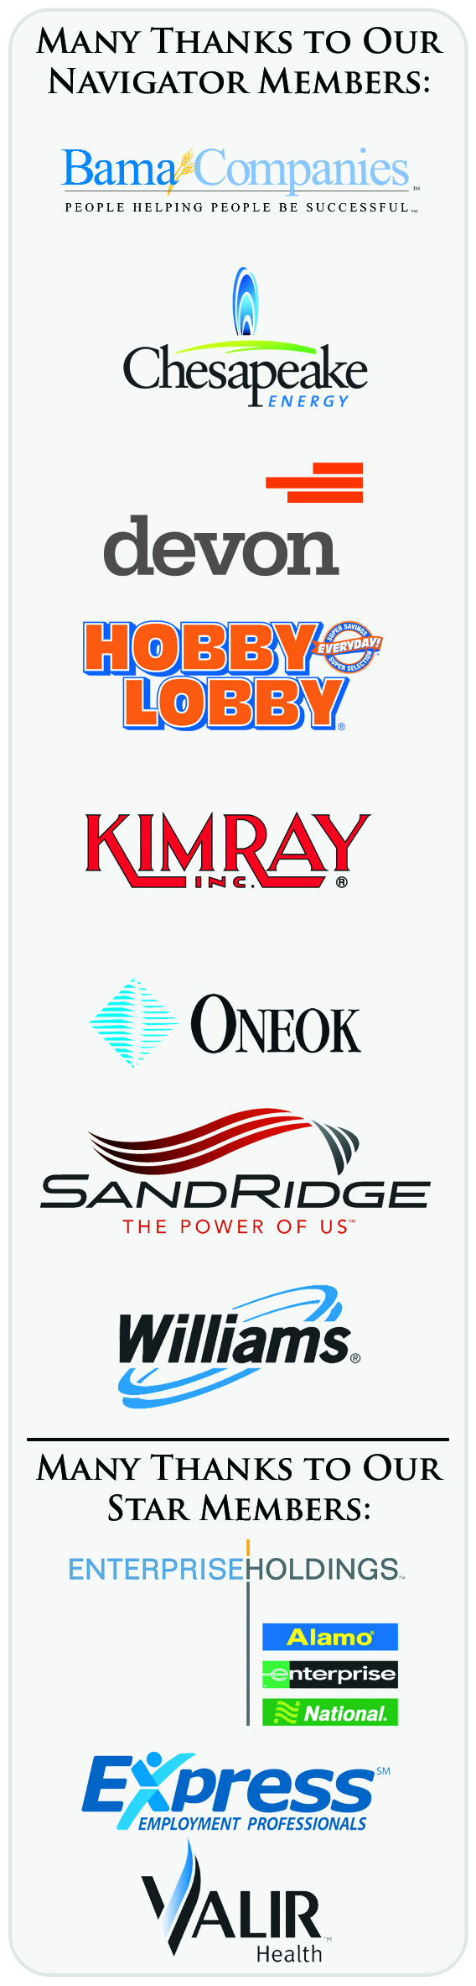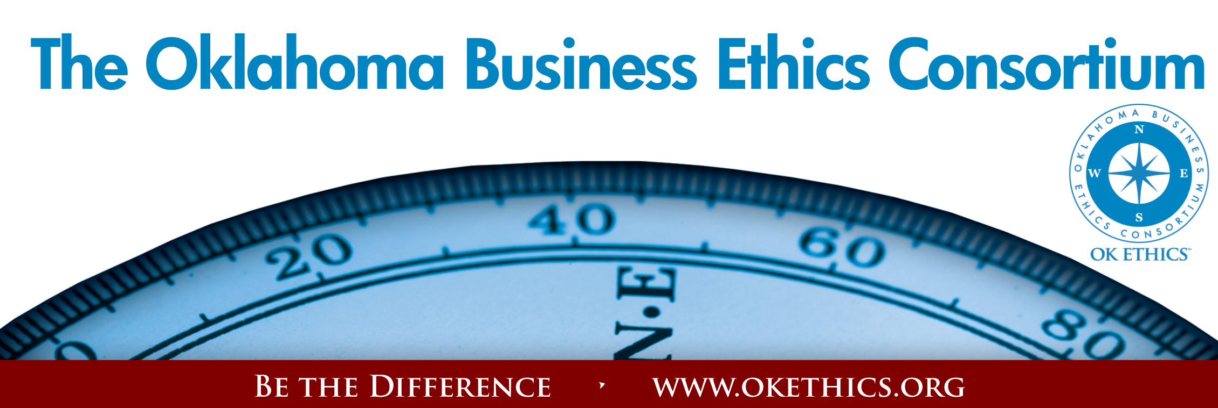Agenda – October 5, 2011
- Welcome & Announcements – Garyl Geist, Chief Operating Officer,
Oklahoma Allergy & Asthma Clinic; President of OK Ethics Board
- Join/Renew Now - OK Ethics Annual Membership Drive Underway
- Statewide Student Ethics Challenge – Oct. 29 at
Oklahoma Christian University, Edmond
- Upcoming Events – Shannon Warren, Founder, OK Ethics &
Judge Bill Blew, The Olive Branch
- Intentional Interaction - Discussion Questions
- How does one arrive at agreement about moral truths that transcend differences in individual’s upbringing and perspectives?
- Is it possible to develop a community standard for moral truth?
- How would you describe the ethical climate in this country
- Do you think we are at risk of losing our freedom because of a lax commitment to ethical behavior, or are things okay?
Note: OK Ethics encourages interaction among our members for the purpose of building relationships with others who share an interest in promoting Oklahoma values of integrity at work. At the same time, this is not an appropriate forum for sales activities.
- Introduction - Myrna Schack Latham, Attorney & Shareholder, McAfee &
Taft; General Counsel, OK Ethics Board of Directors
Keynote Speaker: Mr. Chuck Colson, “Doing the Right Thing”
- Adjourn

Membership levels:
$7500 – Navigator = Prepaid for16 attendees at each event + Compass Awards with a portion of dues donated to the OK Ethics Foundation supporting our educational initiatives.
$5000 - Oklahoma Stars = Prepaid for 8 attendees at each event + Compass Awards with a portion of dues donated to the OK Ethics Foundation supporting our educational initiatives.
$3000 – Horizon = Prepaid 8 attendees at each function except Compass Awards.
$1500 – Leading = Prepaid 2 attendees at each function including Compass Awards.
$ 500 – Trailblazer = Prepaid 1 attendee at each function except Compass Awards.
$ 350 – Frontier = 8 attendees at each function; meal costs excluded
* Complimentary memberships are available for 501c3 qualified non-profits.
$ 75 - Scout = 1 attendee at each function; meal costs excluded
*Complimentary memberships are available at the Scout level for those who have been recently laid off.

REMINDER: PLEASE PICK UP CPE’S AT CONCLUSION OF THIS MEETING
Oklahoma Business Ethics Consortium Guiding Principles
Adopted July, 2004
To ensure that the Consortium fosters positive characteristics of integrity in the successful achievement of its goals, these Guiding Principles were discussed and adopted (with revisions) during a milestone planning session held by Consortium leaders in Stroud on June 18, 2004. These principles were developed based on the Character First Institute's values and philosophies.
I. Responsibility to Self and Others:
- Service:
  - Passion for promoting ethics and integrity
  - Encouraging the promotion of ethical behavior through personal actions and
  - Sharing ideas and resources
  - Responsibility and accountability for fulfilling the mission of the Consortium.
- Collaboration:
  - Achievement of common goals through the promotion of ethical, mutually beneficial relationships
  - Service to the Consortium over promotion of self-interest
  - Cooperation emphasized over competition in promoting ethical business conduct
  - Members collaborate by being constructively engaged in discussions regarding ethics
  - Seeking consensus in interactive discussions regarding ethical matters.
- Respect:
  - Members may become aware of confidential information shared by others in an effort to determine an ethical course of action. We ask members to be sensitive in recognizing and respecting the efforts made toward achieving ethical behavior. In that vein, public disclosure of this information is discouraged.
  - We respect other members and the process by:
    - Exhibiting listening skills and actively listening to discussions
    - Being open to other points of view and outcomes
  - We are an inclusive organization and demonstrate this by welcoming members who are in different stages of learning as applied to ethical behavior.
II. Lead with Integrity
- Dependability:
  - Members are asked to demonstrate their support of this initiative by consistently attending meetings.
- Initiative:
  - Recruiting other members who have demonstrated a desire to promote ethical behavior in their organizations.
  - Recognizing what needs to be done to help promote the Mission of the Consortium and taking action to assist in that effort.
- Honor:
  - Members are asked to honor the Consortium through the practice of integrity and ethical behavior in their business dealings.
  - We express gratefulness to our hosts, sponsors and speakers.
  - Realizing that each of us is in a mode of continual learning, we demonstrate humility, care and compassion when sharing our thoughts and knowledge.
- Courage:
  - Speak the truth with confidence and encourage others to do the same.
III. Inspire Trust
- We serve and promote the cause of truth with integrity, objectivity and fairness to all persons.
  - We hold ourselves accountable by consistently honoring our word.
  - We extend trust abundantly to those who have earned it.
  - Trust, once earned, will not be taken for granted, manipulated or abused.

VOLUNTEER RECOGNITION:
OK Ethics has no staff and relies on volunteers to achieve the organization’s successful pursuit of Oklahoma’s values of integrity at work.
Registration Team: These dependable individuals show up every month to diligently record our guests’ attendance and handle the collection of fees:
- Mark Neumeister, Chairperson; D. R. Payne & Associates:
Join our team - Contact our leadership
Membership & Recruiting: Shannon Warren, Founder, OK Ethics
warrenokla@cox.net or 858-2233
Public Relations: Kellian Schneider, Owner, FullForce Branding & Marketing; kellian@fullforcebusiness.com
Ambassadors: Linda Streun, Director of Human Resources,
Ideal Homes, lindastreun@ideal-homes.com
Registration: Mark Neumeister, D. R. Payne; 272-0511; moneumeister@drpayne.com
  - Elaine King, Chaparral Energy
  - Mary Kay Huggard, Principal Technologies
  - Debbie Forester, Devon Energy
- Joe Walker, Chairperson (Prepaid members); Wilbanks Security
  - Marvinette Ponder, Devon Energy
  - Susan Pate, Stinnett & Associates
  - Renee Kissler, Accel Financial Staffing
  - Carla Driskill, Accel Financial Staffing
  - Brandy Weldon, SandRidge Energy
Ambassador Team: These friendly people welcome our guests each month and assist in helping them locate seats:
Team Leaders:
- Linda Streun, Ideal Homes of Norman: Co-Chairperson
- Chade Nash, Gabbard & Company; Co-Chairperson

Team Members:

- Brent Martens, Accounting Principals
- Jenny Hatton, Boeing
- Jenny Juvera, Ideal Homes of Norman
- Kristy Boone, Ideal Homes of Norman
- 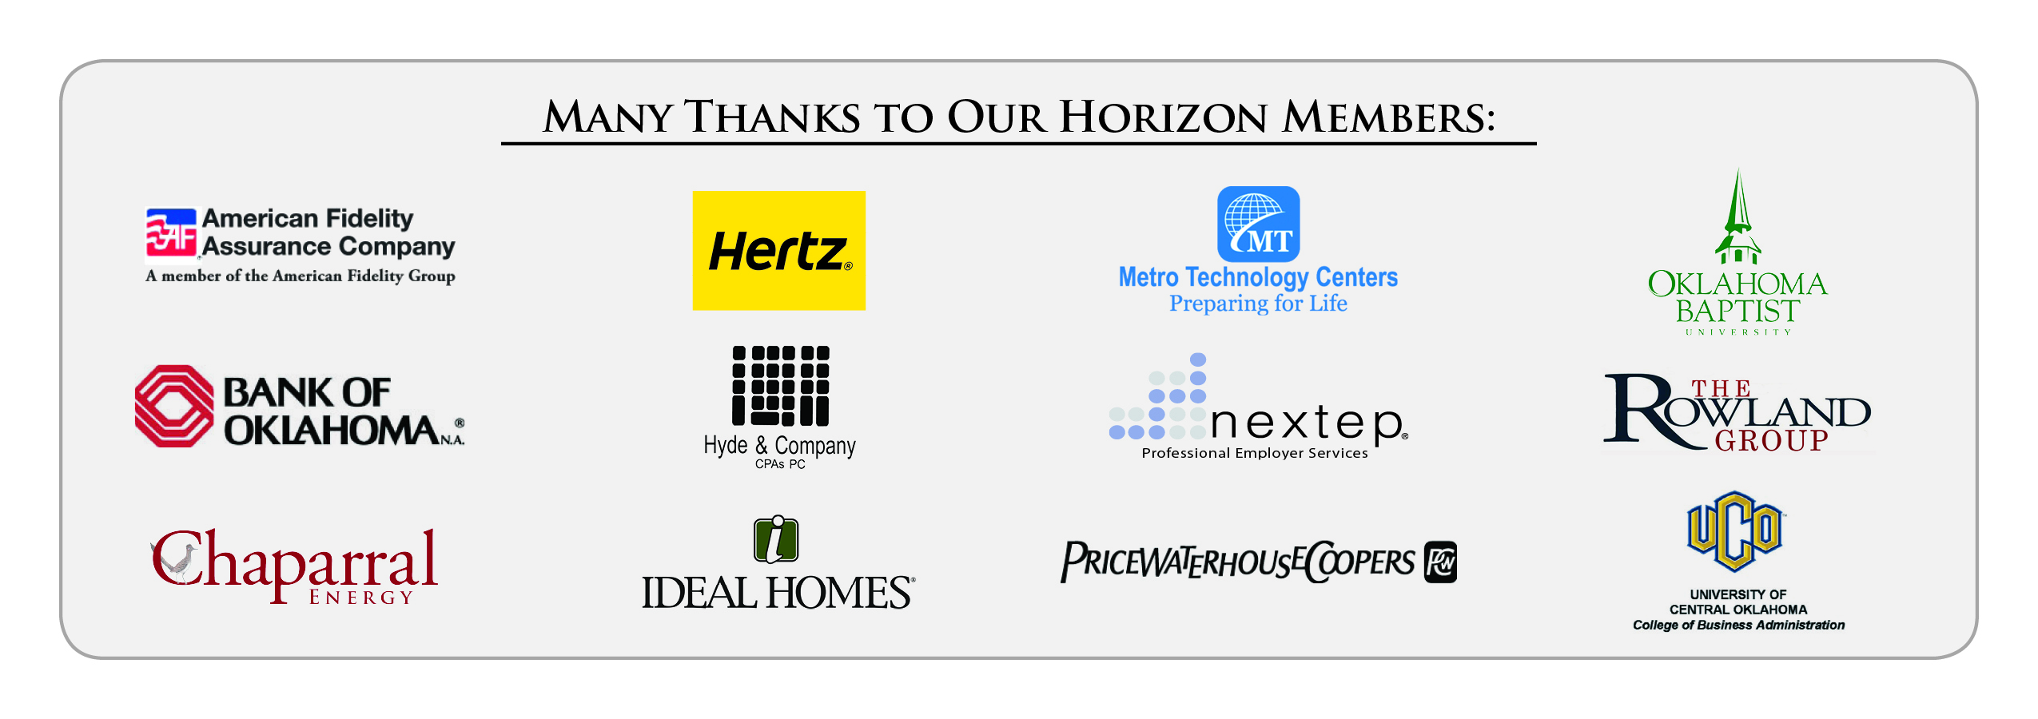Tonya Purvine, Valir Health
- Ginger Castleberry, Valir Health
- Scott Harris, Oklahoma Baptist University
- Wayne Hart, Legal Shield
- Mary Nemcok, Gabbard & Company
- Jana Mahoney, Hyatt
- Lucius Crandall, SandRidge Energy

Agendas: Metro Technology Centers, Quality Services and Media Departments
CPE certificates: Michael Mount, Oklahoma Accountancy Board
Accounts Receivable Reconciliation: Susan Pate, Stinnett & Associates
Pre-meeting slide show: Connie Rutz, Maximum Multimedia Creations
CHUCK COLSON

CPE CERTIFICATES
It is the responsibility of participants to demonstrate applicability of each program as it relates to his/her area of practice. OK Ethics makes no guarantees. Also, attendees must be present to accept CPE certificates and these will be issued at the back of the room upon the conclusion of the program. Please note that we do not have the manpower capabilities to email these later. CPE certificate recipients must be registered on our attendance list to receive a certificate, so please be sure to check in with the registration team.
“Doing the Right Thing”
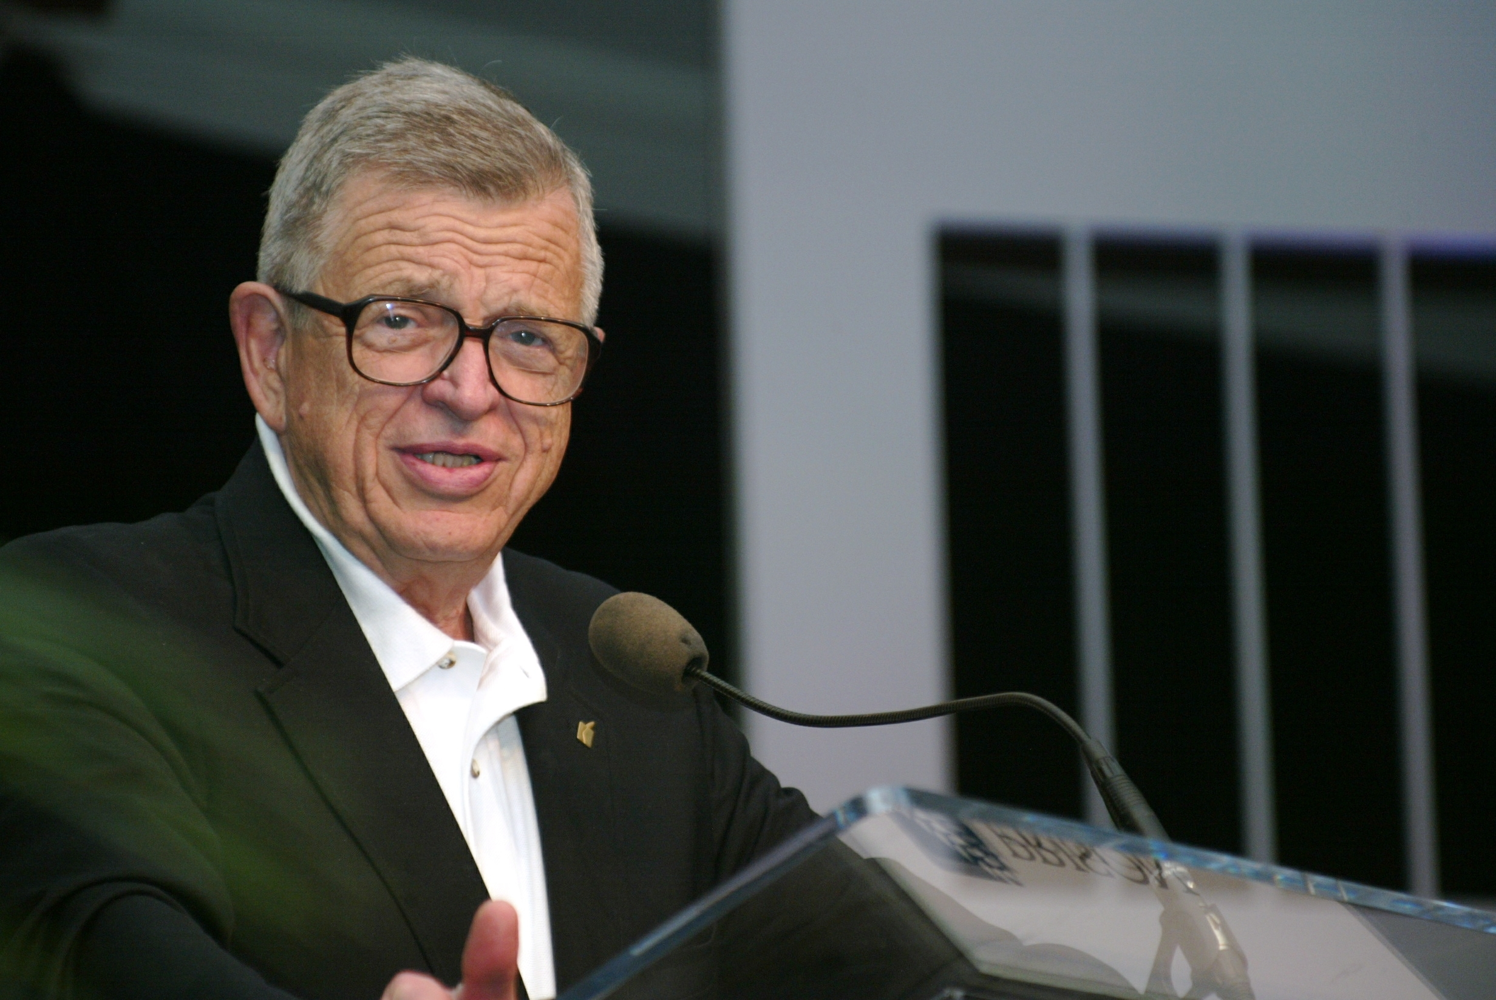Chuck Colson is a popular and widely known author, speaker, and radio commentator. A former presidential aide to Richard Nixon and founder of Prison Fellowship, BreakPoint, and the Chuck Colson Center for Christian Worldview, he has written several books, including Born Again, Loving God, How Now Shall We Live?, The Good Life and The Faith Given Once, for All. His weekday radio broadcast, BreakPoint, airs to two million listeners. In 1993, Chuck was awarded the prestigious Templeton Prize for Progress in Religion; the one million dollar prize—along with all speaking fees and book royalties—are donated to the ministry. In 2008, President Bush conferred on him the second highest civilian award of the U.S. government, the Presidential Citizen Medal for his humanitarian work with Prison Fellowship. He is a graduate of Brown University and George Washington Law School, receiving his juris doctor with honors. He served in the United States Marine Corps, attaining the rank of Captain. He and his wife Patty have three children and five grandchildren.

Synopsis:
The Problem: our society is experiencing an ethics crisis.
The Challenge: Moral relativism, utilitarianism, obsessive selfishness, and greed compete for our hearts and minds.
The Solution: We need to retrain our intellect and restrain our wills to recover our virtue.
The Takeaway: Do the right thing. Learn more about ethics and morality; learn how to reform character and recover virtue; take steps to live ethically and morally in your family, business, community.

Outline:

How Did We Get Into This Mess?
Moral failures led to financial collapse
We have a culture of moral relativism
Ethics are not taught or practiced
Is There Such a Thing as Truth – a Moral Law we can all Know?
The Roots of Moral Authority
Moral Relativism vs Absolute Truth
Natural Law
From Where Does Justice Originate?
If We Know What is Right, Are We Capable of Doing It?
A Return to Virtuous Living
Retraining the Mind, Restraining the Will
Cultivating Character
The Role of Community, Family
What Does it Mean to be Human?
A Matter of Life and Death
How Do We Treat One Another as Human
Beings?
Utilitarianism, Pragmatism,
Euthanasia, Human Dignity
Can There Be Ethical Behavior in the Marketplace?
Giving back vs greed
Corporate Responsibility
Michael Novak’s Three-Legged Stool
Is Ethical Behavior in Public Life a Possibility?
What Are Human Rights?
What is the Role of Government in Society

The Colson program is recommended for anyone interested in developing a greater insight into ethical issues facing our workplaces and our nation. Emphasis will be on virtue ethics, a common understanding of morality as it pertains to the workplace and society, as well as society’s obligations to promote strong standards of ethical behavior.

***Advance Reservations Required***
v. Preview of Upcoming Events Shannon Warren, Founder, OK Ethics
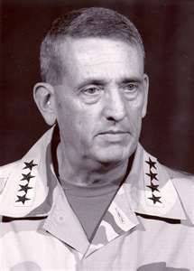GENERAL TOMMY FRANKS
“Everyday Heroes”
Wednesday, November 16
Active service, veterans and Red Cross volunteers will receive discounted registration.

NOTE:
DIFFERENT LOCATION
St. Luke’s United Methodist Church
222 Northwest 15, Downtown OKC

ACCOUNTABILITY PANEL DISCUSSION
Wednesday, December 14
The Petroleum Club, Downtown OKC
 | 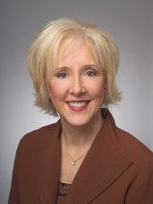 | 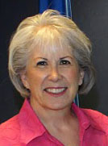 | 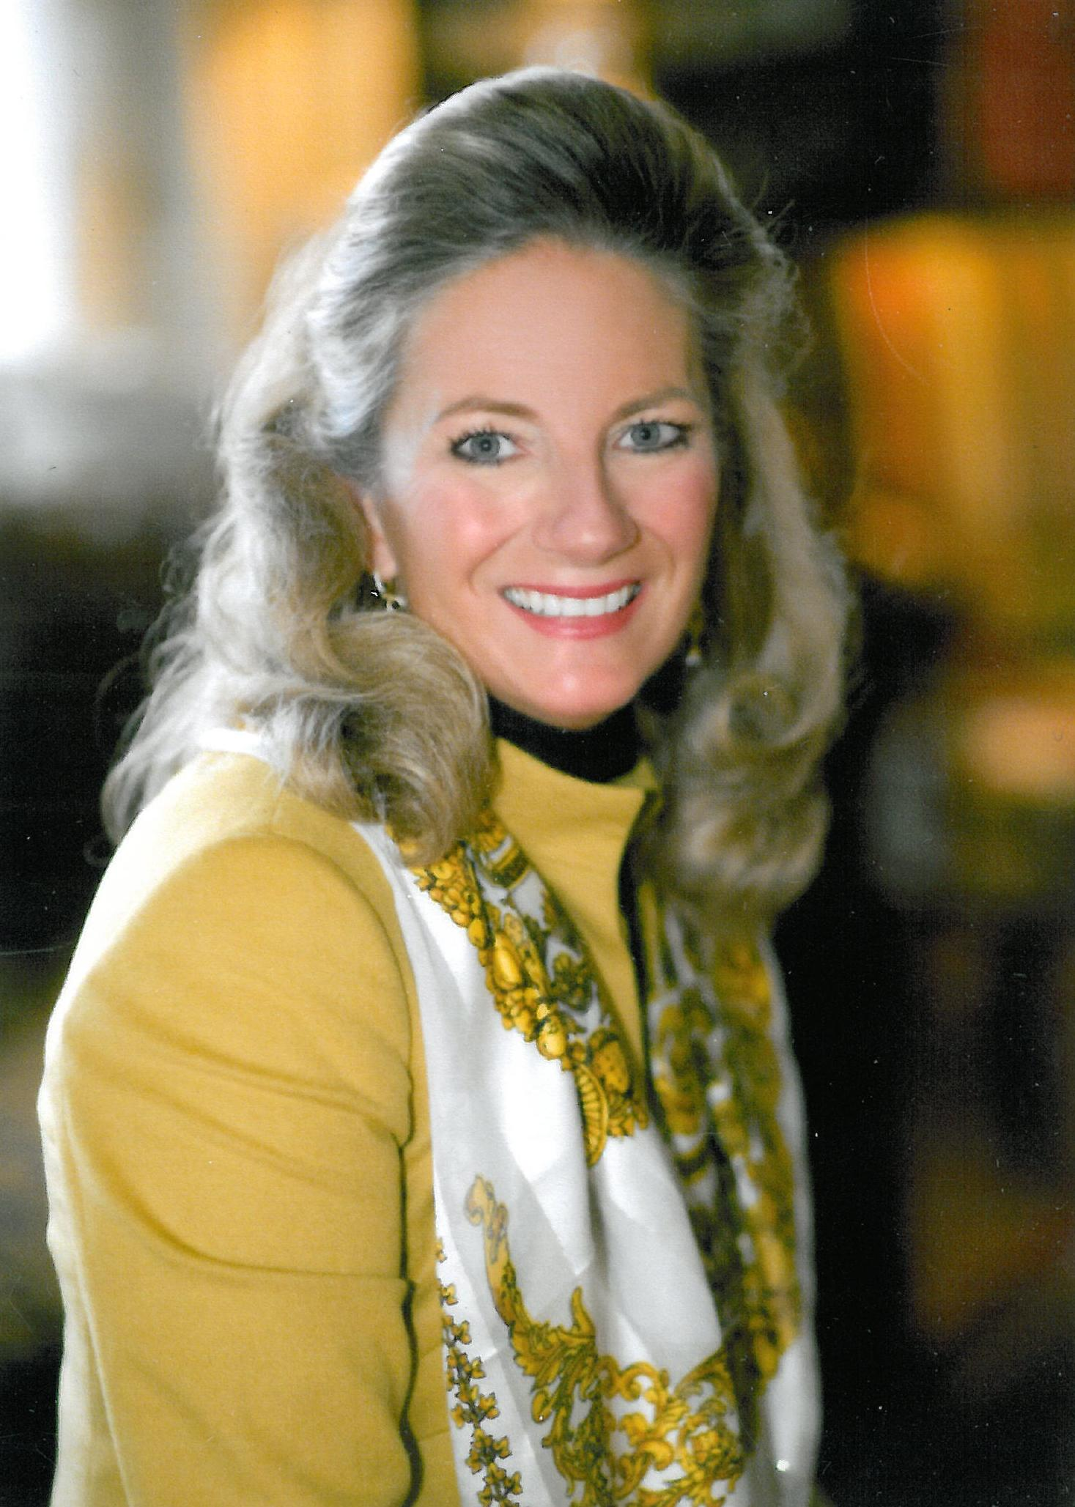 | 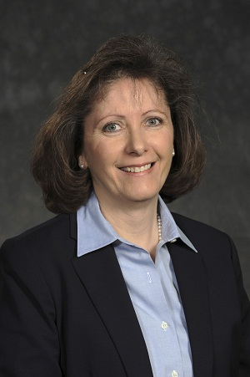
Heather Griswold  Oklahoma Quality Award Foundation | Joy LaBar  SandRidge Energy | Jean Warner  Oklahoma Women’s Coalition | Marnie Taylor  Oklahoma Center for Non-Profits | Myrna Schack Latham  McAfee & Taft

PLEASE POST THIS ON YOUR BULLETIN BOARD & INVITE OTHERS TO ATTEND

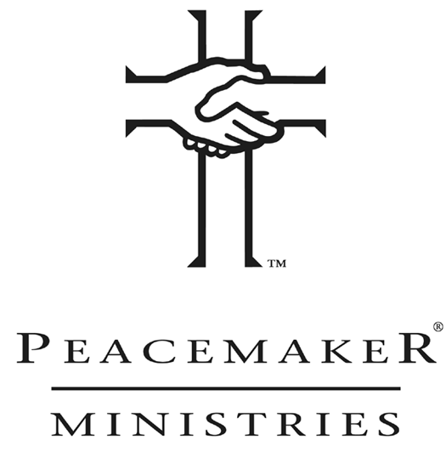“RESOLVING EVERYDAY CONFLICT”
October 20 & 21
Recommended for 8 CPE’s
Special ½ Day Workshop - $50
Facilitated by Judge Bill Blew
Contact Shannon Warren at warrenokla@cox.net
if you are interested in attending

Conflict is costly in the workplace (and at home)
- 22% of workers say they put less effort into work because of conflict at the office
- Conflicts resulting in the loss of an employee can cost 150% of the employee’s annual compensation (managers ~ 250%)
- 60-80% of all difficulties in organizations stem from strained relationships, not from
Employers can lose up to 25% of an employee’s productivity due to family strife or divorce deficits in skills or motivation.
***Seating Limited***
First come, first served basis
Note that this is a bonus program –$50 per person that will include materials and lunch.
It is a Biblically-based program but is not preachy in content or tone.

Four G’s of Peacemaking
  - Go to Higher Ground
  - Get Real About Yourself
  - Gently Engage Others
  - Get Together on Lasting
Solutions

Four Promises of Forgiveness
  - I will not dwell on this incident
  - I will not bring this incident up and use it against you
  - I will not talk to others about this incident
  - I will not allow this incident to stand between us or hinder our personal relationship

Tulsa OK Ethics Chapter Presents:

ENCORE PRESENTATION: A View from the White House – October 27
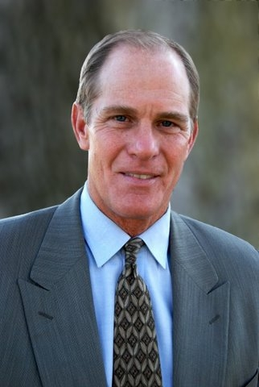Steve Ford will bring an insiders view of the White House with fascinating little anecdotes. He will offer the lessons learned first as the son of President Gerald R. Ford and then as successful actor in Hollywood for over 25 years. His focus will be on choices we all are forced to make regarding character, integrity and ethical leadership in the workplace and at home with our families. Steve asks the question...."What do you do when no one is looking?".....that is our true character.

Steve will bring a broad range of inspirational stories from the Nixon pardon to how the Ford family dealt with their mother's bout with alcoholism. Within each story Steve will challenge the listener to rethink their own lives and daily choices regarding character, integrity and ethical leadership. The question being what kind of stories will your children and grandchildren being telling about your character.

General Program Disclaimer:
Members of the Oklahoma Business Ethics Consortium frequently share information concerning various issues and developments that may have legal implications. The discussions, commentary, and handouts at Consortium meetings or presentations to other organizations are for general informational purposes only. They cover only some aspects of the subject topic, and do not constitute a complete legal analysis of the topic or how it might apply to any particular set of facts. Before taking any action based on information presented during a Consortium event, participants are encouraged to consult a qualified attorney. The observations and comments of presenters at Consortium meetings and networking are the views and opinions of the presenter and do not constitute the opinion or policies of the Consortium or any of its members. Presenters are respectfully requested to avoid profanity, preaching, politics and self-promotion during their lectures

UPCOMING EVENTS FOCUSED ON INTEGRITY AT WORK
Oklahoma City University Distinguished Speaker Series
Bill Moyers - OCU 7:30 pm October 26th
THE TRUTH OF YOUR LIFE

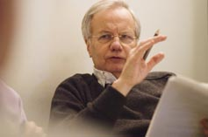If journalism is indeed a sacred calling, then few men are more qualified to be its high priest than Bill Moyers. In an age of shallow, hyper-partisan entertainment formats that pass for news, one voice has never wavered in service to the highest aim of a journalist: to find and speak the truth. Born in Oklahoma in 1934, Bill Moyers began his journalism career at age 16 as a cub reporter on the Marshall News Messenger, served as press secretary to Lyndon Johnson, and went on to establish Public Affairs Television in 1986. The winner of more than 30 Emmy Awards, Moyers has produced some of the finest documentaries ever seen on public television, and has interviewed some of the most important thinkers in the world, from Joseph Campbell on the power of myth, to Elie Wiesel on the power of evil. His candid work on death and dying, addiction, and myriad threats to our democracy include a body of work that is without equal in public broadcasting. Like a canary in the journalistic coal mine, Bill Moyers refuses to go quietly into retirement without telling the biggest story of our time: that we have lost any semblance of an independent press, and have largely sold our democracy to the highest bidder. The good news is that Bill Moyers will be back next year with a new program on American Public Television, entitled, Moyers and Company.

On this evening, Moyers will reflect on the case for and against optimism in a world where everything that's tied down is coming loose and the only hero who can save us is right there in the mirror, staring back at you. After almost half a century in broadcast journalism, the PBS veteran is known for seeing the world as it is, without rose-colored glasses, even as he imagines a more confident future.

OK ETHICS VISION:
To be recognized as a statewide and national forum for
promoting business ethics.

Programs Focused on Integrity - (Not affiliated with OK Ethics)

For eight years, we have been inspired by our friendship with Character First. Leaders with this organization provided the wisdom and insight for OK Ethic's Guiding Principles. Go to www.characterfirst.com to learn more about tools to help you integrate character and ethics into your organizational culture, or contact John Burnett or Steven Menzel at 405-815-0001

Orientation Seminar Dates for Oklahoma City:
When: October 27, 9am–4pm
Where: PHF Conference Center (downtown Oklahoma City)
Cost: $95/person for Member Organizations ($295 non-members)
Includes lunch and materials
Register: Call 877-357-0001 or email: events@characterfirst.com
Additional Training: Ask us about on-site Orientation Training for your management team; 100-Minute Workshops on specific topics; and Full-Day Leadership Seminars for executives and high-potential employees.

Character Council of Central Oklahoma
October 25 – Robin Jones: Tolerance
November 15 – Tom Pace: Resourcefulness
December 13 – Nathan Mellor: Endurance
January 24 – Kelli Dyer Frye: Boldness
February 28 – Sheriff John Whetsell
Cost is $15 per person; Reservations made via luncheon@characterok.org

