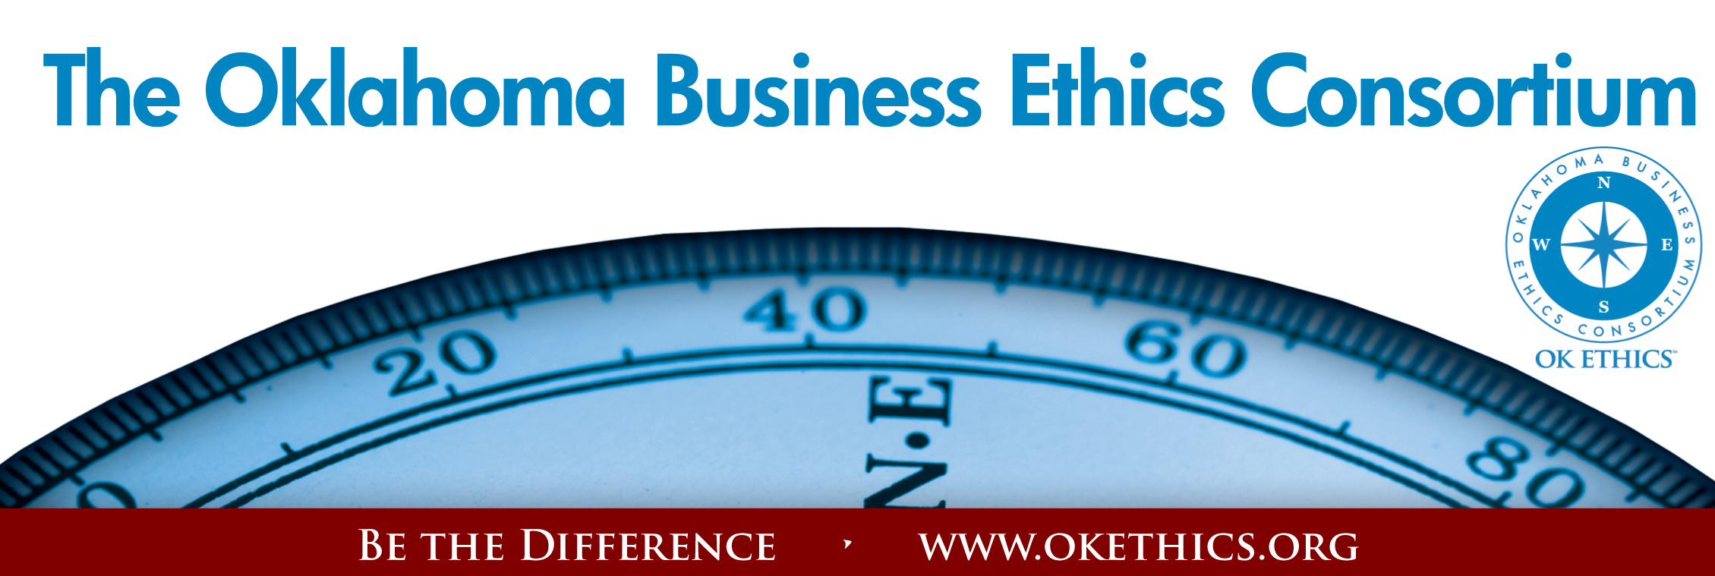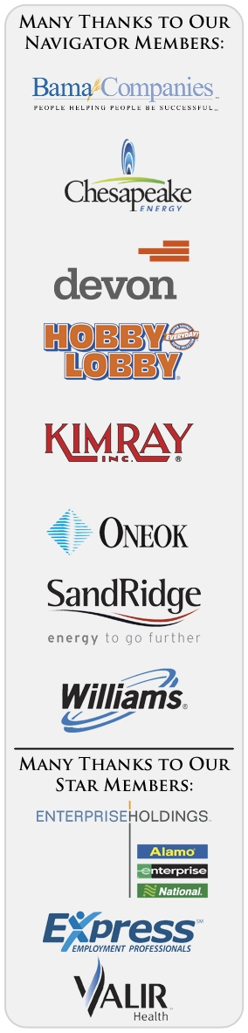Agenda – September 14, 2011
- Welcome & Announcements
- Join/Renew Now - OK Ethics Annual Membership Drive Underway
- Statewide Student Ethics Challenge – Oct. 29 at Okla Christian
- Intentional Interaction - Grace and courage are not always easy character attributes. Briefly describe examples of where you have seen this exhibited in the workplace and how it impacted you.
Note: OK Ethics encourages interaction among our members for the purpose of building relationships with others who share an interest in promoting Oklahoma values of integrity at work. At the same time, this is not an appropriate forum for sales activities.
- Upcoming Events – Shannon Warren, Founder, OK Ethics
- Introduction – Todd Lisle, OK Ethics Board; Managing Partner, BKD, LLP
Keynote Speaker: Steve Ford, “A View from the White House”
- Adjourn

- Welcome & Kudos Garyl Geist, President, OK Ethics;
Chief Operating Officer, Oklahoma Allergy & Asthma Clinic
- Membership levels: No dues or meals increase for FY11-12
$7500 – Navigator = Prepaid for16 attendees at each event + Compass Awards with a portion of dues donated to the OK Ethics Foundation supporting our educational initiatives.
$5000 - Oklahoma Stars = Prepaid for 8 attendees at each event + Compass Awards with a portion of dues donated to the OK Ethics Foundation supporting our educational initiatives.
$3000 – Horizon = Prepaid 8 attendees at each function except Compass Awards.
$1500 – Leading = Prepaid 2 attendees at each function including Compass Awards.
$ 500 – Trailblazer = Prepaid 1 attendee at each function except Compass Awards.
$ 350 – Frontier = 8 attendees at each function; meal costs excluded
* Complimentary memberships are available for 501c3 qualified non-profits.
$ 75 - Scout = 1 attendee at each function; meal costs excluded
*Complimentary memberships are available at the Scout level for those who have been recently laid off.
RENEW/JOIN BY SEPTEMBER 9 TO BE INCLUDED IN SPECIAL PROMOTIONAL BOOKLET - Will be distributed at the October meeting.
Many thanks to these flagship companies for their early renewal and continued commitment: Hobby Lobby, The Bama Companies, ONEOK, SandRidge, Kimray, Devon, Chesapeake Energy, Ideal Homes and Oklahoma Baptist University!
REMINDER: PICK UP CPE’S AT CONCLUSION OF THIS MEETING
Oklahoma Business Ethics Consortium Guiding Principles
Adopted July, 2004
To ensure that the Consortium fosters positive characteristics of integrity in the successful achievement of its goals, these Guiding Principles were discussed and adopted (with revisions) during a milestone planning session held by Consortium leaders in Stroud on June 18, 2004. These principles were developed based on the Character First Institute's values and philosophies.
I. Responsibility to Self and Others:
- Service:
  - Passion for promoting ethics and integrity
  - Encouraging the promotion of ethical behavior through personal actions and
  - Sharing ideas and resources
  - Responsibility and accountability for fulfilling the mission of the Consortium.
- Collaboration:
  - Achievement of common goals through the promotion of ethical, mutually beneficial relationships
  - Service to the Consortium over promotion of self-interest
  - Cooperation emphasized over competition in promoting ethical business conduct
  - Members collaborate by being constructively engaged in discussions regarding ethics
  - Seeking consensus in interactive discussions regarding ethical matters.
- Respect:
  - Members may become aware of confidential information shared by others in an effort to determine an ethical course of action. We ask members to be sensitive in recognizing and respecting the efforts made toward achieving ethical behavior. In that vein, public disclosure of this information is discouraged.
  - We respect other members and the process by:
    - Exhibiting listening skills and actively listening to discussions
    - Being open to other points of view and outcomes
  - We are an inclusive organization and demonstrate this by welcoming members who are in different stages of learning as applied to ethical behavior.
II. Lead with Integrity
- Dependability:
  - Members are asked to demonstrate their support of this initiative by consistently attending meetings.
- Initiative:
  - Recruiting other members who have demonstrated a desire to promote ethical behavior in their organizations.
  - Recognizing what needs to be done to help promote the Mission of the Consortium and taking action to assist in that effort.
- Honor:
  - Members are asked to honor the Consortium through the practice of integrity and ethical behavior in their business dealings.
  - We express gratefulness to our hosts, sponsors and speakers.
  - Realizing that each of us is in a mode of continual learning, we demonstrate humility, care and compassion when sharing our thoughts and knowledge.
- Courage:
  - Speak the truth with confidence and encourage others to do the same.
III. Inspire Trust
- We serve and promote the cause of truth with integrity, objectivity and fairness to all persons.
  - We hold ourselves accountable by consistently honoring our word.
  - We extend trust abundantly to those who have earned it.
  - Trust, once earned, will not be taken for granted, manipulated or abused.

VOLUNTEER RECOGNITION:
OK Ethics has no staff and relies on volunteers to achieve the organization’s successful pursuit of Oklahoma’s values of integrity at work.
Registration Team: These dependable individuals show up every month to diligently record our guests’ attendance and handle the collection of fees:
- Mark Neumeister, Co-Chairperson; D. R. Payne & Associates:
- Mary Vaughan, CPA; Co-Chairperson
- Joe Walker, Chairperson (Prepaid members); Grant Thornton
- Marvinette Ponder, (Prepaid members); Devon Energy
Ambassador Team: These friendly people welcome our guests each month and assist in helping them locate seats:
Team Leaders:
Help!
We need 25 ambassadors to assist with the October event.
- Tere Bettis, Coppermark Bank: Co-Chairperson
- Linda Streun, Ideal Homes: Co-Chairperson

Team Members:
- Wayne Hart, Prepaid Legal
- Brent Martens, Accounting Principals
- Scott Harris, Oklahoma Baptist University
- Bob Byrne, Boeing (Retired)
Agendas: Bertha Robinson, Metro Technology Centers
CPE certificates: Michael Mount, Oklahoma Accountancy Board
Name tags: Kim Whyburn, Devon Energy
Accounts Receivable Reconciliation: Susan Pate, Stinnett & Associates
Pre-meeting slide show: Connie Rutz, Maximum Multimedia Creations
Join our team - Contact our leadership
  - Membership & Recruiting: Shannon Warren, Founder, OK Ethics
warrenokla@cox.net or 858-2233
  - Public Relations: Kellian Schneider, Owner, FullForce Branding & Marketing; kellian@fullforcebusiness.com
  - Ambassador Co-Chairs: Tere Bettis, Vice President of Human Resources, Coppermark Bank, TBettis@coppermarkbank.com or Linda Streun, Director of Human Resources,
Ideal Homes, lindastreun@ideal-homes.com
  - Registration: Mark Neumeister, D. R. Payne; 272-0511; moneumeister@drpayne.com

OK ETHICS VISION:
To be recognized as a statewide and national forum for
promoting business ethics.

General Program Disclaimer:
Members of the Oklahoma Business Ethics Consortium frequently share information concerning various issues and developments that may have legal implications. The discussions, commentary, and handouts at Consortium meetings or presentations to other organizations are for general informational purposes only. They cover only some aspects of the subject topic, and do not constitute a complete legal analysis of the topic or how it might apply to any particular set of facts. Before taking any action based on information presented during a Consortium event, participants are encouraged to consult a qualified attorney. The observations and comments of presenters at Consortium meetings and networking are the views and opinions of the presenter and do not constitute the opinion or policies of the Consortium or any of its members. Presenters are respectfully requested to avoid profanity, preaching, politics and self-promotion during their lectures
ABOUT YOUR PRESENTER
Steve Ford will bring an insiders view of the White House with fascinating little anecdotes. He will offer the lessons learned first as the son of President Gerald R. Ford and then as successful actor in Hollywood for over 25 years. His focus will be on choices we all are forced to make regarding character, integrity and ethical leadership in the workplace and at home with our families. Steve asks the question...."What do you do when no one is looking?".....that is our true character.

CPE CERTIFICATES
It is the responsibility of participants to demonstrate applicability of each program as it relates to his/her area of practice. OK Ethics makes no guarantees. Also, attendees must be present to accept CPE certificates and these will be issued at the back of the room upon the conclusion of the program. Please note that we do not have the manpower capabilities to email these later. CPE certificate recipients must be registered on our attendance list to receive a certificate, so please be sure to check in with the registration team.

Steve will bring a broad range of inspirational stories from the Nixon pardon to how the Ford family dealt with their mother's bout with alcoholism. Within each story Steve will challenge the listener to rethink their own lives and daily choices regarding character, integrity and ethical leadership. The question being what kind of stories will your children and grandchildren being telling about your character.

- Do you live your life in a way that allows positive change and
transformation regarding building your legacy

- Ethical leadership decisions....Long term results verses short term
results

- What kind of ethical leader will you be remembered for?

- Why is character so important?

- Are you teaching and investing ethical leadership qualities to those
around you?

v. Preview of Upcoming Events Shannon Warren, Founder, OK Ethics
***Advance Reservations Required***

CHUCK COLSON
“Doing the Right Thing”
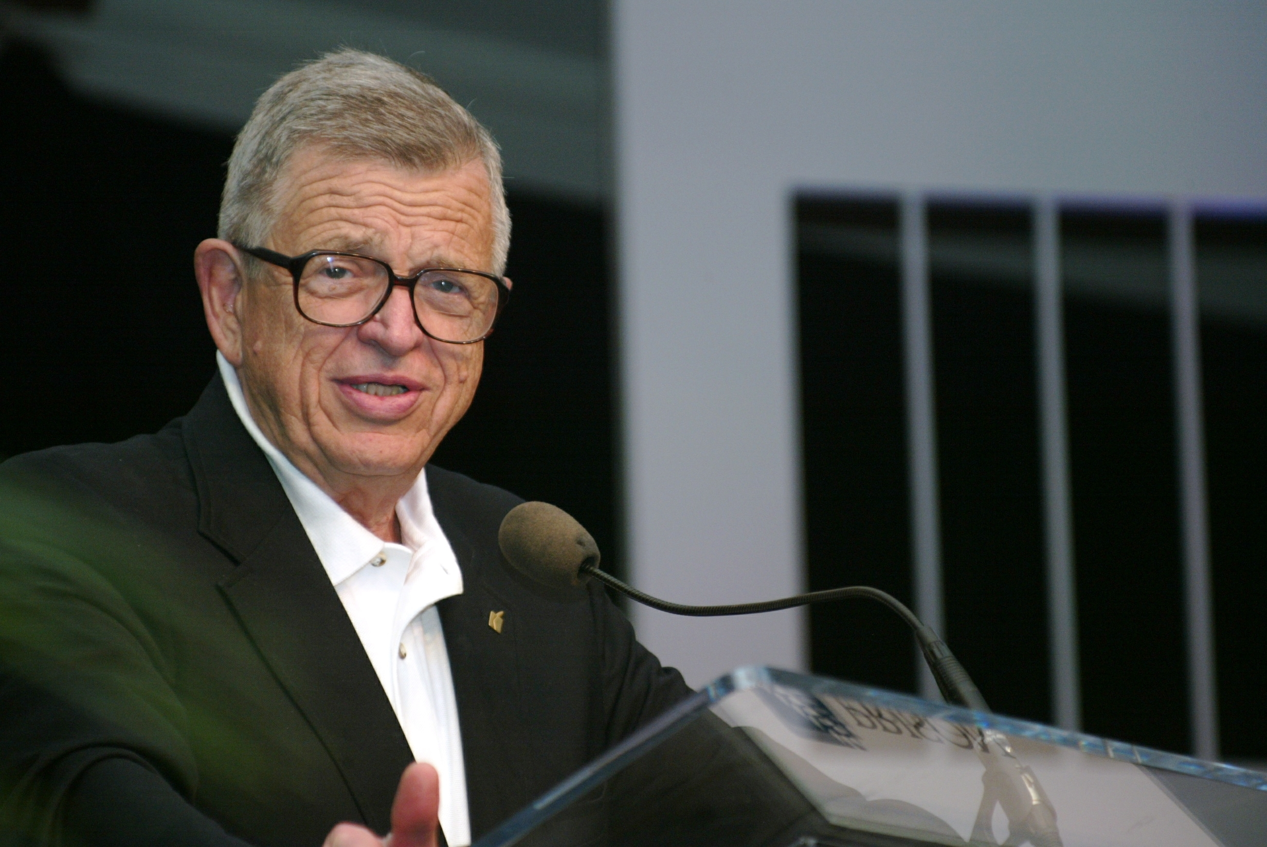
Insights from this special counsel to Richard Nixon during the Watergate Era
NOTE:
DIFFERENT DATE & LOCATION
Wednesday, October 5
11:30 to 1:00; Cox Convention Center
____________________________________________________________________________________

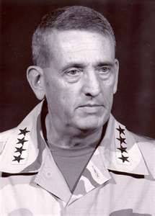GENERAL TOMMY FRANKS
“Everyday Heroes”
Wednesday, November 16
Active service, veterans and Red Cross volunteers will receive discounted registration.

NOTE:
DIFFERENT LOCATION
St. Luke’s United Methodist Church
222 Northwest 15, Downtown OKC
ACCOUNTABILITY PANEL DISCUSSION
Wednesday, December 14
The Petroleum Club, Downtown OKC
 | 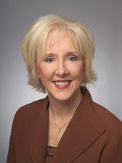 | 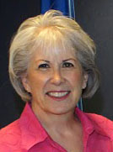 | 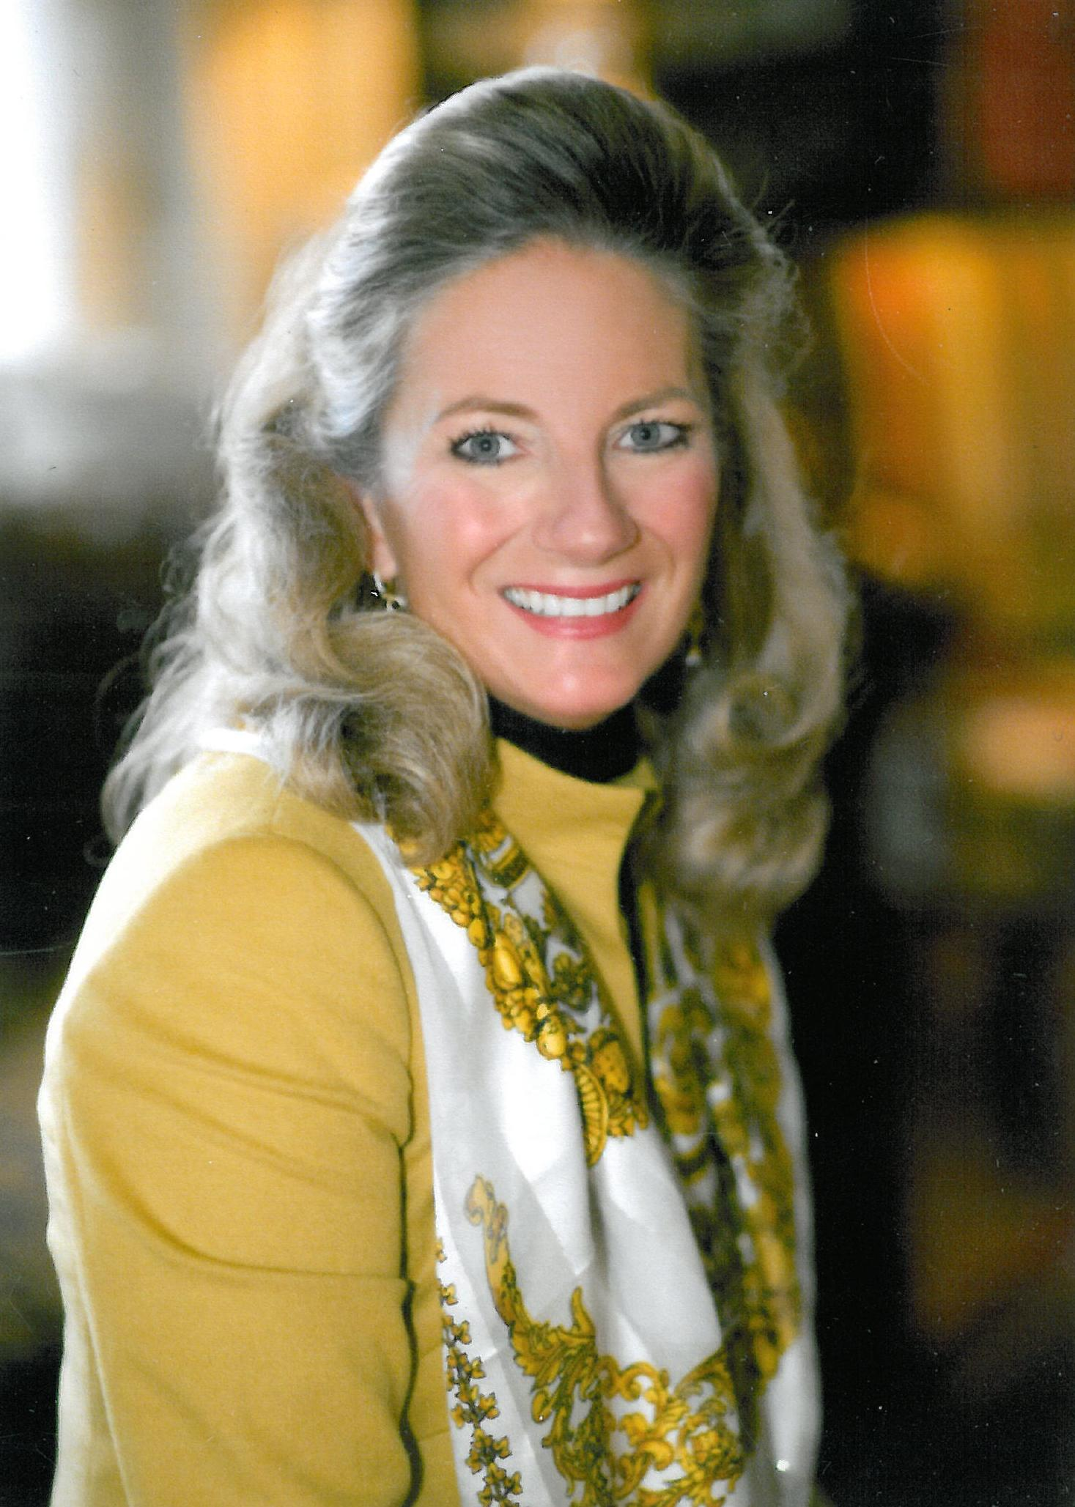 | 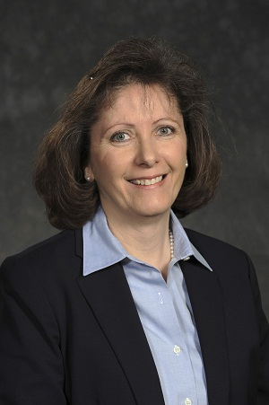
Heather Griswold  Oklahoma Quality Award Foundation | Joy LaBar  SandRidge Energy | Jean Warner  Oklahoma Women’s Coalition | Marnie Taylor  Oklahoma Center for Non-Profits | Myrna Schack Latham  McAfee & Taft
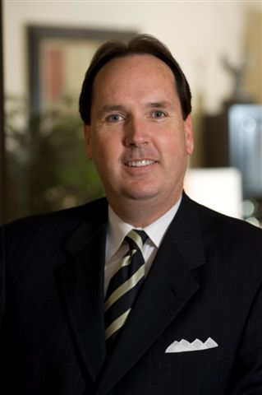
Tulsa OK Ethics Chapter Presents:

David Woods, CEO of Giant Partners
“The Insignificant Leader: Building a Culture of Growth Based on Authenticity and Integrity”
Thursday, September 22
Doubletree Hotel, Downtown Tulsa
OKC Members may also attend Tulsa programs.
VI. UPCOMING EVENTS FOCUSED ON INTEGRITY AT WORK
(Not affiliated with OK Ethics)

For eight years, we have been inspired by our friendship with Character First. Leaders with this organization provided the wisdom and insight for OK Ethic's Guiding Principles. Go to www.characterfirst.com to learn more about tools to help you integrate character and ethics into your organizational culture, or contact John Burnett or Steven Menzel at 405-815-0001

September 20: Hiring for Character & Competence; presented by Nathan Mellor
9:00 to 4:00; PHF Conference Center, Downtown OKC; $395 per person;
Register by calling (877)357-0001 or email events@characterfirst.com
As Jim Collins says in his book Good to Great, the question is “first who, then what.” When you have the right people on your team—with the right character and competence—your potential for success skyrockets!
This one-day program will be a hands-on, roll-up-your-sleeves training session for Human Resource managers and anyone else tasked with recruiting, hiring, or evaluating employees. Bring your employment applications, interview forms, job descriptions, and evaluation methods to see how they can be tweaked—or reinvented—to reflect your corporate values and make your workplace somewhere you and your coworkers can be proud of.

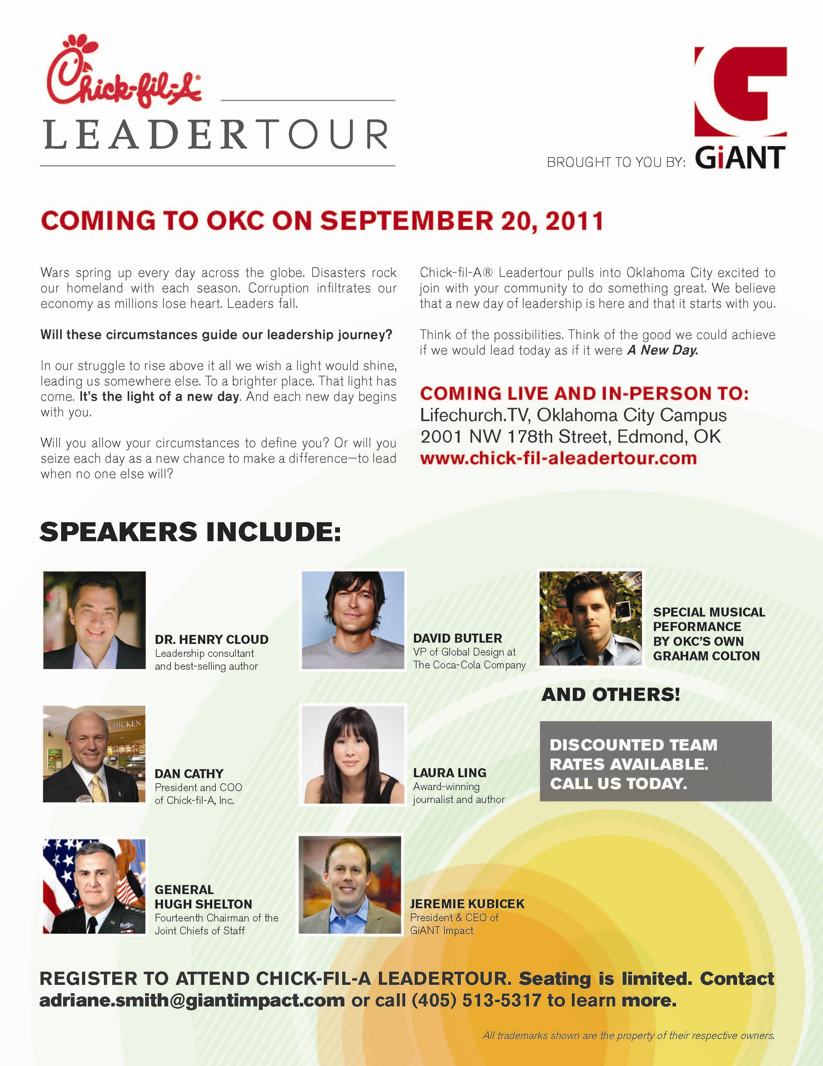

Character Council of Central Oklahoma's Annual Awards Luncheon
September Guest Speaker

The Honorable Lt. Gov. of Oklahoma,
Todd Lamb
Tuesday, September 27 from 11:30 to 1:30
Will Rogers Theatre.
Please RSVP by 3:00 PM on Friday, September 23

email: luncheon@characterok.org
^{or call 818-5025}

September Character Trait:
Respect
"Showing high regard for self, others and property. Respect includes cooperation, listening to understand others and mutual support"

